 |  | Draft Number: DZ 4441
DRAFT | New Zealand Standard | Postal Ballot Draft 2  6 June 2008  DZ 4441
DRAFT | New Zealand Standard | Swimming Pool Design Standard
DRAFT | New Zealand Standard | Committee: P4441
DRAFT | New Zealand Standard | DO NOT USE THIS DRAFT AS A STANDARD –  IT MAY BE ALTERED BEFORE FINAL PUBLICATION
DRAFT | New Zealand Standard | Standards New Zealand
DRAFT | New Zealand Standard | Private Bag, Wellington. Fax: 04 498 5994

DZ 4441

New Zealand Standard

Swimming Pool Design Standard

Superseding NZS 4441:1985

ISBN 1-86975-087-X
Committee Representation

This Standard was prepared under the supervision of the Swimming Pool Design Committee (P 4441) for the Standards Council established under the Standards Act 1988.
The committee consisted of representatives of the following nominating organisations:
Association of Consulting Engineers New Zealand
Building Research Association of New Zealand Ltd.
Business New Zealand
Filtration and Pumping Commercial Ltd.
Institution of Professional Engineers New Zealand
Local Government New Zealand
Ministry of Health
New Zealand Master Pool Builders' Guild
New Zealand Recreation Association
Sport and Recreation New Zealand
Swimming New Zealand
Water Safety New Zealand

Acknowledgement
Standards New Zealand gratefully acknowledges the contribution of time and expertise from all those involved in developing this Standard.

Copyright
The copyright of this document is the property of the Standards Council. No part of it may be reproduced by photocopying or by any other means without the prior written approval of the Chief Executive of Standards New Zealand unless the circumstances are covered by Part III of the Copyright Act 1994.

Published by Standards New Zealand, the trading arm of the Standards Council, Private Bag 2439, Wellington 6140. Telephone (04) 498 5990, Fax (04) 498 5994, Website http://www.standards.co.nz.

Contents
Committee representation IFC
Acknowledgement IFC
Copyright IFC
Referenced documents …7
Latest revisions …7
Review of Standards …7
Foreword …8

1 GENERAL 10
1.1 Scope 10
1.2 Interpretation 10
1.3 Definitions 10
1.4 Abbreviations 11
2 LEGISLATION AND RELEVANT STANDARDS 12
2.1 Design 12
2.2 Relevant New Zealand Standards 12
2.3 Types of swimming pools Error! Bookmark not defined.
3 LIMITING DIMENSIONS 13
3.1 Plan dimensions 13
3.2 Slope of pool bottoms 13
3.3 Diving pools 13
4 STRUCTURAL DESIGN AND CONSTRUCTION 14
4.1 Design 14
4.2 Watertightness testing of pool structures 14
5 POOL SURFACES AND SURROUNDS 16
5.1 General 16
5.2 Internal pool surfaces 16
5.3 Pool surrounds 17
6 POOL COMPONENTS AND FITTINGS 19
6.1 General 19
6.2 Avoidance of entrapment 19
6.3 Steps and ladders 19
6.4 Handrails 19
6.5 Other fittings 19
6.6 Bulkheads 19
6.7 Moveable floors 20
7 SIGNAGE AND MARKINGS 21
7.1 Pool safety signs 21
7.2 Lane marks 21
7.3 Depth marks 21
8 MISCELLANEOUS SERVICES 22
8.1 Lighting 22
8.2 Air heating and ventilation 22
8.4 Water heating 22
8.5 Noise 23
9 POOL WATER INLETS AND OUTLETS 24
9.1 Filling and make-up water connection 24
9.2 Pool inlets 24
9.3 Pool water outlets 24
10 OVERFLOW CHANNELS AND THE TOPS OF POOL WALLS 26
10.1 General 26
10.2 Capacity 26
10.3 Construction 26
11 Skimmers 28
11.1 General 28
11.2 Capacity 28
11.3 Construction 28
12 WATER CIRCULATION AND TREATMENT 29
12.1 Circulation and treatment system 29
12.2 Flow capacity 29
12.3 Treatment processes 29
12.4 Materials 30
12.5 Installation 30
13 WATER TREATMENT CIRCULATION RATE 31
13.1 Pool bathing load, circulation rate and turnover period 31
14 WATER QUALITY, DISINFECTION, AND pH CONTROL 33
14.1 Water quality objective 33
14.2 Disinfection and pH 33
14.3 Disinfection 33
14.4 Control of pH 35
14.5 Alkalinity control 35
14.6 Testing equipment 35
15 RECIRCULATION PUMPS 36
15.1 Flow capacity 36
15.2 Pump details 36
15.3 Pump motors 36
16 HAIR AND LINT STRAINER 37
16.1 General 37
17 SAND AND MULTI-MEDIA FILTERS 38
17.1 Types 38
17.2 Filter medium 38
17.3 Filter medium bed depth 38
17.4 Rate of filtration 38
17.5 Backwashing 38
17.6 Filter construction 39
17.7 Pressure tests 39
17.8 Ancillary equipment 39
17.9 Coagulation 40
18 PRECOAT FILTRATION 41
18.1 Types 41
18.2 Filter medium or filter aid 41
18.3 Rates of filtration 41
18.4 Construction and design 41
18.5 Precoating 41
18.6 Body feed 42
18.7 Ancillary equipment 42
19 PLANT ROOMS AND CHEMICAL STORAGE 43
19.1 General 43
19.2 Chemical storage 43
19.3 Chlorine rooms 43
19.4 Filter rooms 43
20 BALANCE TANKS 44
20.1 General 44
20.2 Balance tank dimensions 44
20.3 Inlet from pool overflow channels 44
20.4 Make-up water inlet 44
20.5 Flow-equalising connection 45
20.6 Overflow 45
20.7 Pump suction 45
20.8 Drain 45

Appendix
A - Design considerations (Informative) 55
B - Pool dimensions and temperatures (Informative) 57
C - Protection against entrapment (Informative) 61
D - Precoat filter medium selection (Informative) 72
E - Balance tank operation (Informative) 73

Tables
1 - Pool water surface areas used to determine instantaneous bathing load 31
2 - Indicative turnover period for public pools 32
C1 – Probes for assessment of head and neck entrapment in completely bound openings 51

Figures
C1 -Test template for assessment of head and neck entrapment in partially bound and v-shaped openings 51
C2 - Method of insertion of the ‘B’ portion of the test template 52
C3 - Method of insertion of the ‘A’ portion of the test template 53
C4 - Finger rods 54
C5 - Rotation of the 8 mm diameter finger rod 54
E1 - Operation of a balance tank 58

Referenced Documents
Reference is made in this document to the following:
NEW ZEALAND STANDARDS
NZS 3101.1&2:2006 Concrete structures Standard
NZS 3106:1986 Code of practice for concrete structures and for the storage of liquids
NZS 3114:1987 Specification for concrete surface finishes
NZS 4121:2001 Design for access and use of buildings and facilities by disabled persons
NZS 4219:1983 Specification for seismic resistantance of engieering systems in buildings
NZS 4251:1974 Code of practice for solid plastering
NZS 4303:1990 Ventilation for acceptable indoor air quality
NZS 5826:2000 Pool water quality
NZS 8500:2006 Safety barriers and fences around swimming pools, spas and hot tubs
NZS 8690:2003 Water safety signage

JOINT AUSTRALIAN/NEW ZEALAND STANDARDS
AS/NZS 1680.1:2006 Interior lighting – General principles and recommendations
AS/NZS 1838:1994 Swimming pools – Premoulded fibre-reinforced plastics – Design and fabrication
AS/NZS 1839:1994 Swimming pools – Premoulded fibre-reinforced plastics – Installation
AS/NZS 2107:2000 Acoustics - Recommended design sound levels and reverberation times for building interiors
AS/NZS 2927:2001 The storage and handling of liquefied chlorine gas

AMERICAN STANDARDS
ANSI A108, A118, American national standards for the installation ceramic tile
A136: 1999
ANSI/APSP-7:2006 American national standard for suction entrapment avoidance in swimming
pools, wading pools, spas, hot tubs, and catch basins
ASME A112.19.8:2007 Suction fittings for use in swimming pools, wading pools, spas and hot tubs
BRITISH STANDARDS
BS PAS 39:2003 Management of public swimming pools, water treatment systems, water treatment plant and heating and ventilation systems.
BS 5383: 1986 Specification for material identification of steel, nickel alloy and titanium
parts 1 – 4 alloy tubes by continuous character marking and colour coding of steel tubes

Other Publications
Electricity Regulations 1997
Federation Internationale de Natation Amateur Handbook (FINA)
New Zealand Building Code
Seismic design of storage tanks (New Zealand society of earthquake engineering)
SPARC Pool Guide

New Zealand Legislation
Building Act 2004
New Zealand Building Code
Fencing of Swimming Pools Act 1987
Hazardous Substance and New Organisms Act 1996 (HSNO)
Health (Drinking Water) Act 2007
Local Government Act 2002
Resource Management Act 1991
Electricity Act 1992 and Amendments
Electricity Regulations 1997 and Amendments

Websites
http://www.canoepolo.org.nz
http://www.dbh.govt.nz
http://www.fina.org
http://www.legislation.govt.nz
http://www.nzsynchro.co.nz
http://www.poolsafe.org.nz
http://www.sparc.org.nz
http://www.swimming.org.nz
http://www.underwaterhockey.org.nz
http://www.waterpolo.org.nz
Latest Revisions
The users of this Standard should ensure that their copies of the above-mentioned New Zealand Standards are the latest revisions. Amendments to referenced New Zealand and Joint Australian/New Zealand Standards can be found at http://www.standards.co.nz.
REVIEW OF STANDARDS
Suggestions for improvement of this Standard will be welcomed. They should be sent to the Chief Executive, Standards New Zealand, Private Bag 2439, Wellington 6140.
Foreword
This is a substantial revision of the 1985 'Code of practice for swimming pools' now elevated to full Standard status and with a name change reflecting this.

NZS 4441:2008 Swimming pool design Standard covers the essentials of design and construction of public, institutional, and private freshwater and seawater swimming pools, and the provision of water treatment facilities.

Prospective pool purchasers are given guidance on the suitable minimum requirements to set when contracting for design and construction of swimming pools or when contemplating the purchase of a pool.

Pool designers and builders receive clear guidelines for the requirements that should be met to achieve safety and good operational management.

Building regulators may use the Standard as a model acceptable solution for approving design and construction plans to assist with building consent approvals and monitoring the construction process.

Complying pools will meet with minimum standards for safety and health.

GENERAL

Scope
This Standard covers the essential aspects of the design and construction of swimming pools and the provision of water treatment facilities, for new pools and the upgrading of existing facilities. It does not cover ancillary works such as spectator accommodation and enclosing structures except in so far as these are likely to affect the design and construction of the pools themselves. It does not cover the provision of heating or other special equipment, operation and maintenance, nor the supervision necessary to ensure the physical safety of pool users.

Interpretation
For the purposes of this Standard, the word 'shall' refers to requirements that are essential for compliance with the Standard, while the word 'should' refers to practices that are advised or recommended.

The term 'Informative' has been used in this Standard to define the application of the Appendix to which it applies. An 'Informative' Appendix is for information and guidance. Informative provisions do not form part of the mandatory requirements of this Standard.

Clauses prefixed 'C' and printed in italic type are intended as comments on the corresponding clauses. They are not to be taken as the only or complete interpretation. The Standard can be complied with if the comment is ignored.

Appendix A provides a list of items to consider for best design practice.

Definitions
For the purposes of this Standard the following definitions shall apply.

Alkalinity |  | A measure of the capacity of the water to neutralise acids or alkalis, primarily because of the presence of bicarbonates, and provide a buffer against drastic pH changes. Expressed as mg/L calcium carbonate (CaCO₃) or equivalent
Balance tank |  | A conserving reservoir that temporarily stores water displaced by bathers and wave action in the pool. Used for level deck and other pools in which a constant water level is required
Building consent authority |  | A Building Consent Authority as defined in the Building Act 2004 and includes a Territorial Authority or a private body acting within the scope of their approval
Coagulant |  | A substance or agent that aids or produces an aggregation of suspended particles dispersed in a liquid
Domestic pool |  | Any pool located in the grounds of a private dwelling and intended to be used by members of the household and their invited guests
FINA |  | The Federation Internationale de Natation Amateur
Geothermal pool |  | Any pool which uses geothermal water, that is, water that emerges from the ground at an uncontrolled temperature generated by geological forces. This includes recirculating systems and unfiltered, non-recirculating ('fill and draw') systems
Pool |  | Any water-holding structure, wholly or partially of artificial construction, designed for swimming and/or other aquatic uses, having a circulation and filtration system, or is emptied after use, regardless of location  NOTE – For further clarification refer to the Fencing of Swimming Pools Act (http://www.legislation.govt.nz)
Public pool |  | Any pool other than a domestic pool. This category includes commercial, school, institutional, club, hospitality industry, community (including gated communities and apartment buildings) and local authority pools
Sea water pool |  | A pool with water drawn directly from the sea
Septum (plural septa) |  | Parts of a diatomaceous earth filter element consisting of cloth, wire screen, on which other porous filter medium or filter aid is deposited
Skimmer |  | A device sometimes used as a substitute for overflow channels to provide recirculation of water from the surface of a pool
Spa pool and hot tubs |  | Pools which are designed for use with heated water (35 ― 40°C) with or without air jets. (For the purposes of this Standard the terms ‘spa pools’ and ‘spas’ are interchangeable)
Territorial authority (TA) |  | Any city, district or regional council.  NOTE – For further clarification refer to the Local Government Act (www.legislation.govt.nz)

Abbreviations
The following abbreviations are used in this Standard:
DE Diatomaceous earth
ELWL Extreme low water level
HSNO Hazardous substances and new organisms Act
NLWL Normal low water level
NZBC New Zealand Building Code
OL Overflow level
UV Ultra violet light

legislation and relevant standards

Design
Design shall be in accordance with all of the following legislation:
- The Building Act;
NOTE The Building Act requires that building consents shall be obtained by the owner for all new swimming pools, spa pools and hot tubs, and for any alterations to existing swimming pools, spa pools, and hot tubs, and their barriers/fences. It is the responsibility of the territorial authority (TA) or building consent authority (BCA) to enforce this requirement.
- The Fencing of Swimming Pools Act;
- The Hazardous Substances and New Organisms Act; (HSNO);
- The Resource Management Act.

Relevant New Zealand Standards
The following Standards provide useful additional information which augments this Standard and should be consulted during the design stage:
NZS 3101: 2006 Concrete structures Standard, specifies minimum requirements for the design of reinforced and prestressed concrete structures.
NZS 3106:1986 Code of practice for concrete structures and for the storage of liquids, sets out the requirements for the design, materials and construction of concrete structures for the storage of liquids.
NZS 4121:2001 Design for access and use of buildings and facilities by disabled persons, gives requirements for making buildings and facilities accessible to and usable by people with physical disabilities.
NZS 5826:2000 Pool water quality covers the essential aspects of the operation and maintenance of pools relating to pool water quality criteria, including reference to methods of water treatment.
NZS 8500:2006 Safety barriers and fences around swimming pools, spas and hot tubs aims to assist avoiding pool related drowning by providing options which are designed to deny, delay or detect unsupervised entry to the swimming pool area by young children.
NZS 8690:2003 Water safety signage sets out the requirements for the design, application, and testing of safety signs and flags including signs incorporating graphic symbols and signs intended for use where activities may be undertaken on or near bodies of water. This includes public pools.

POOL TYPES AND LIMITING DIMENSIONS

Types of swimming pools

The safest and most efficient use of a pool is made when diving is prohibited and the depth of water does not exceed 1.5 m.
NOTE –
- Diving pools (see 3.3) should be separate from swimming pools;
- Swimming pools should have the minimum depths necessary for their intended uses (see section 3);

Multi-purpose pools (used for both swimming and diving) have taken a spoon-shaped form in longitudinal section because of the variety of functions they must satisfy. This type is considered more hazardous than single-purpose pools, difficult to supervise, restrictive in use, and expensive to construct. For these reasons this type of multi-purpose pool is not recommended.

Plan dimensions
Swimming pools may be rectangular and/or free-form in plan. Guidance is given in Appendix B on pool dimensions for various uses.

Slope of pool bottoms

Design the pool to be easily and completely drained, preferably by gravity.

For the safety of users, the maximum slope of a pool bottom shall be:
- Where the water depth does not exceed 900 mm and the pool bottom has an anti-slip surface (minimum coefficient of friction measured wet of 0.50) – 1 in 12;
- Where the water depth does not exceed 1650 mm – 1 in 15;
- Where the depth of water exceeds 1650 mm – no restriction.

Diving pools

Diving pools shall comply with the dimensional requirements specified in the FINA Handbook.

STRUCTURAL DESIGN AND CONSTRUCTION

Design
The structure of a swimming pool shall be designed in accordance with Clauses B1/VM1 and B2/AS1 of the New Zealand Building Code. Loadings due to ground pressure, water pressure, and seismic effects shall be allowed for. Allowance shall be made for hydrostatic pressures in the pool-empty condition and during construction.
Replaceable liners shall be designed for a minimum of 15 years durability.
The structure of a public swimming pool shall be designed by, or the design shall be certified by, a Chartered Professional Engineer.
Joints in a pool structure shall be designed where appropriate, to take into account shrinkage, temperature effects, and forces from ice formation. The design shall accommodate movements between parts while retaining the integrity and watertightness of the structure at the joints.

Watertightness testing of pool structures
On completion of every water-holding pool structure (including balance tanks) and before painting or tiling, the structure shall be tested for watertightness as follows:
- Clean out the structure, plug all drains, shut all necessary valves, and fill with water to above normal overflow channel (or skimmer) level so that the overflow channel is full;
- Add no further water for 72 hours;
- Determine the amount of leakage each 24 hours over that 72 hour period by measuring the fall in water level.
The pool structure shall not be considered watertight if there is a fall in water level of 5 mm or more over any 24-hour period, after allowing for evaporation and/or rainfall. The amount of evaporation and rainfall shall be determined by measuring the change in level of a vertical-sided vessel of water placed on the pool surrounds for the same period.
If this criterion is not met, the structure shall be drained, defects made good, and the test repeated until compliance is achieved.

Design of In-Ground Pools.

Pools in the ground shall be designed so they will withstand all likely external loadings that may be applied by the soil and backfill including suitable allowance for the soil to be saturated if that is possible. The highest loadings from the soil shall be resisted by the pool structure in the pool empty condition.

The pool shall also be designed to resist all forces exerted by the water, including impulsive seismic forces, without reliance on the backfilling or soil.

C4.3.2
This requirement is to make allowance for possible shrinking soils).

Hydrostatic Relief Valves

Hydrostatic relief valves should be installed at the lowest point of all in-ground pools. Designers should note that such valves will not pass a high flow of water so the design should take into account any risk of the ground water table rising above the low point of an empty pool and causing the pool to "float" or be damaged by the hydrostatic pressure before this can be relieved by ground water entering the pool through the hydrostatic relief valves.

The designer should check the pressure at which the hydrostatic relief valves operate and ensure that the pool bottom has sufficient mass and strength to resist this pressure without damage.

Where there is a risk of a high water table occurring it is desirable to install a permanent inspection tube so the ground water level can be determined before the pool is emptied.
NOTE – Most insurance policies specifically exclude damage to swimming pools caused by hydrostatic pressure.

Pool SURFACES and surrounds

General
The whole of the internal surface of every pool, including overflow channels and balance tank, shall have a smooth, dense finish capable of being easily cleaned.

All corners, recesses or irregularities shall be constructed to avoid the growth of algae and slime on any internal surface including steps. Floor to wall junctions should be coved.

The floor of every pool should be of a light colour, so that objects on the floor will be clearly visible in good light.

Joint materials shall be designed to accommodate the movements to which they may be subjected. Where other finishes cover these materials they shall be designed and built so that there is no effect on the behaviour of the joint and the cover materials are securely supported.

Internal pool surfaces

Maintenance of pool internal surface finishes
The maintenance of internal surface finishes shall be considered in the design of the pool.

C5.2.1
For some surface finishes, such as epoxy coatings, maintenance requirements will be less in indoor pools than in outdoor pools. Ceramic tiles and vinyl linings are most commonly used. Tiles are easily cleaned but are difficult to repair or replace if cracked or broken. Paint and plastic surfaces will require periodic repair and/or replacement and, if a paint surface should fail, it can cause serious damage to plant.

Concrete surface finishes
The surface finish of concrete shall be appropriate to the position and subsequent finish of the surface concerned, and should be specified under NZS 3114. Internal pool surfaces which are to receive no further treatment other than painting, should be to the following minimum finishes as specified in
NZS 3114, except that abrupt changes should not exceed 3 mm:
- Vertical off the form surfaces … F4 finish;
- Pool floors ……………………… U3 finish.

Surfaces to be painted should be free of voids and shall be prepared for painting in strict accordance with the paint manufacturer's instructions. In some cases concrete finishes specified in (a) or (b) may require further treatment, such as grinding, etching, blasting or bagging, before painting.

Surfaces to be plastered (see 5.2.4) shall be prepared for plastering as specified in NZS 4251.

Paint
Water- and chemical-resistant paint (for example, plastic, epoxy-resin, or chlorinated rubber base types) may be applied on plaster, but preferably on concrete. Paint shall be applied in strict compliance with the manufacturer's instructions.

Paints prepared with chromium- or manganese-based driers shall not be used, and a certificate that the paint is free from such driers shall be obtained from the paint manufacturer.

Plaster
Plaster shall comply with NZS 4251, provided that additives shall not be used unless satisfactory performance and compatibility with surface finishing materials have been established by testing sample areas.

Tiles
Tiles and associated adhesives sealants and grouts shall be proven in submerged water service.

Ceramic tiles shall be bedded solidly in cement mortar or attached by an adhesive recommended by the tile manufacturer and applied in strict compliance with the adhesive manufacturer's instructions. Water-soluble adhesives shall not be used.

To avoid dislodgement of tiles, special consideration shall be given to other movement effects in the basic construction.

C5.2.5
Solid bedding is important because cavities may lead to the growth of algae that cannot easily be controlled. Reference can be made to BS 5383: Parts 1 – 4 or ANSI A108, A118, A136.

Vinyl
All vinyl is to be certified by the manufacturer as specifically designed for use in and around swimming pools and shall be installed in accordance with the manufacturer’s instructions. An ultra violet light resistant agent shall be incorporated into vinyl for outdoor pools. The vinyl supplier shall specify the range of chemical and temperature conditions that are acceptable for the product in use.

Fibreglass
All fibreglass intended for use shall be certified by the manufacturer as designed for use in swimming pools and shall be installed in accordance with the manufacturer’s instructions, AS/NZS 1838 and AS/NZS 1839. An ultra violet light resistant agent shall be incorporated into fibreglass for outdoor pools. Only chlorine resistant resins shall be used.

Pool surrounds

Separation of pool surrounds from other areas

To reduce the amount of dirt carried into the pool on bathers' feet and to lower the risk of contamination of the pool water with soil and dust-borne disease organisms:
- Spectators should not have access to the immediate pool surround. Areas for spectators should be separated from the pool surround by means of barriers or other devices; and
- Bathers should not have direct access to grassed areas, and lawns should be separated from paved pool surrounds by fences or other barriers.

In public pools there should be provision for prospective bathers to have access to changing rooms and for spectators to have access to any spectator seating without walking on the pool surrounds within 2.5 m of the pool edge, and if possible without walking on the pool surrounds at all.

Width of paved pool surrounds

Public pools
The minimum widths of paved pool surrounds for public pools should be:
- For outdoor pools, 3 m with an average surround width of no less than 4 m;
- For indoor pools, 2 m with an average surround width of no less than 3 m.

Domestic pools
The minimum widths of paved pool surrounds for domestic pools should be:
- For outdoor pools, 1 m with an average surround width of no less than 1.5 m;
- For indoor pools, 1 m.

The widths given in Appendix B should be increased if possible for all pools and particularly for pools that are likely to be used for competitive purposes.

The surrounds of pools of different types within the same enclosure should be wide enough to allow free movement of bathers.

Surface finish and drainage of paved pool surrounds

All pool surrounds, including the tops of pool walls, shall have anti-slip surfaces.

All pool surrounds shall be finished to a minimum fall of 1 in 50 towards the drains.

Outdoor pool surrounds collect both rainwater and splashes from the pool and the drains should be discharged to the stormwater drainage. Indoor pool surrounds collect splashes, cleaning compounds, and wash down water and their drains should be discharged to the sanitary sewer. In order to minimise excessive water loss from splashes the first 500 mm immediately outside a deck level return channel should fall back towards the pool.

Equipment storage spaces
Adequate storage space accessible from the pool surrounds should be provided for items such as:
- Hoses, brooms, and other cleaning equipment;
- Starting blocks, lane markers, and water-polo goal structures;
- Future usage requirements to eliminate hazards by minimising storage on pool-side.

Staff and officials' rooms and facilities
All the following rooms and facilities should be provided appropriate to the size and use of the pool:
- First-aid room – A room readily accessible from the pool and also readily accessible to ambulances. The room should be provided with a wash-hand basin with hot and cold water, and with all necessary first-aid equipment, in particular a stretcher and oxygen equipment;
- Officials' facilities – In pools used for competitive activities, facilities should be provided for timekeepers, judges, and other officials;
- Public address system – A public address system that can be used both by the pool supervisor and by competition officials;
- Public telephone – Facilities should be provided for the installation of a public telephone;
- Water testing room – A separate room may be provided with a sink with hot and cold water, a test bench at least 2 m long and preferably with a glass or other chemical-resistant top, and adequate storage space;
- Staff facilities – Staff changing rooms with adequate locker and drying space, staff lunch room, and other necessary staff facilities. Sanitary facilities for staff must be provided in line with NZBC Clause G1.

POOL COMPONENTS AND FITTINGS

General
There shall be no dangerous obstructions, holes, or projections on the sides or bottom of any pool.

All materials used within the pool shall be corrosion-resistant.

Avoidance of entrapment
All facilities within the pool shall be designed to avoid any possibility that pool users, and children in particular, might be trapped.
Piping exceeding 50 mm in diameter shall be incorporated into the pool wall or bottom or shall be mortared in or otherwise covered to give a smooth finish.
Orifices and gaps shall not readily trap a finger, toe, arm, leg, torso or head. The least dimension of any orifice shall be either less than 8 mm, or between 25 and 50 mm, or greater than 250 mm. See Appendix C for more detail on entrapment avoidance.

Steps and ladders
- Stairs, ladders, recessed steps or ramps shall be provided at convenient points around the perimeter of the pool so that there is at least one means of exit within 25 m of all points of the perimeter of the pool where the water depth is greater than 500 mm.
- Stairs, ladders, or step holes shall be so positioned that pool users are discouraged from swimming beneath diving boards.
- Treads shall be at least 100 mm deep and shall have a non-slip surface. There should be no gap between the top step and the pool wall.
- Steps shall be so designed as to be readily cleaned and to drain into the pool to prevent the accumulation of dirt.
- Every flight of steps shall have a handrail on each side at the top leading over the surround. The handrails may rise to different heights above the surround to cater for pool users of differing size.
- Ladders in pools to be used for competitive swimming shall be readily removable or steps shall be recessed so they don’t project into the pool.
- Steps or ladders that project into the pool shall be so designed that pool users cannot be trapped by them.

Handrails

Handrails in swimming pools should be avoided because they increase the risk of entrapment. Where handrails are used they shall comply with 6.1. Suitable handgrips other than handrails should be formed into the tops of walls. Where handrails are used they shall sit just at or above normal water level.

Handrails must be strong enough to not bend appreciably under the loads that can be expected to be applied to them. The cross-sectional dimension of a handrail shall not be less than 16 mm nor more than 50 mm. Handrails shall be spaced between 25 mm and 50 mm or more than 250 mm off all walls, steps, and other surfaces in the water.

Other fittings
Provision shall be made for the attachment of fittings such as lane ropes, backstroke flags, and starting blocks that are required for the proposed uses of the pool.

Bulkheads
Moveable bulkheads are an option if different pool lengths are required for a specific activity. These are generally used in pools with a length beyond 25 m but can also be used to convert older pools built to an Imperial Standard to Metric length. Where a bulkhead does not extend to the pool floor, the potential for entrapment between the bottom of the bulkhead and the pool floor needs to be taken into account.

Moveable floors

Moveable floors offer greater flexibility in pool use and can alleviate the problem of catering for a number of activities and sports that require different pool depths. Safety issues arising with a change of depth shall be considered if the moveable floor does not cover the entire pool length. The moveable floor should not be moved when swimmers are in the pool.

SIGNAGE AND MARKINGS

Pool safety signs
All safety signage around public pools shall comply with NZS 8690.

Lane marks

The edge lines of swimming lanes shall not be marked.

The centre lines of swimming lanes in pools to be used for competitive swimming shall be marked on the bottom in a dark colour. If paint is used it shall comply with 5.2.3.

Markings in pools for competitive swimming should comply with the FINA Handbook.

Depth marks
The depth of water shall be clearly marked at the deepest point, at the shallowest point, at the point where the depth is 1.5 m, and at points opposite entrances from changing rooms to the pool. If paint is used it shall comply with 5.2.3.

MISCELLANEOUS SERVICES

Lighting
Outdoor pools to be used at night and indoor pools shall be provided with artificial lighting to allow observation of swimmers who may be in difficulty below water level, and to permit safe movement on the surrounding pool surfaces.
Illumination shall be reasonably uniform and comply with the general principles and recommendations of AS/NZS 1680.1 with a minimum of 200 lux at the pool water surface and 100 lux in circulation routes. Where required for special effects, lower illumination levels shall be permitted if appropriate additional pool supervision is provided. Glare or shadows on the water surface shall be reduced to a practical minimum.
Luminaires mounted on poles or on the building shall be provided for public pools and may be supplemented by underwater lighting. Underwater luminaires may be used for other pools and should be considered for all pools deeper than 2 m. Access requirements for maintenance shall be taken into account.

Air heating and ventilation
For indoor pools, ventilation shall be provided to meet the provisions of the New Zealand Building Code clause G4. A mechanical system is preferred. This should supply the minimum outdoor air flow rates required by the Acceptable Solution G4/AS1 of the Compliance Document for the NZ Building Code Approved Documents (refers to NZS 4303),
Air heating and ventilation systems should maintain conditions in the pool hall that are comfortable and safe for users and staff, and prevent unacceptable deterioration of the building structure and fabric. To meet these aims the systems should control space air temperature and relative humidity (and therefore the rate of evaporation from the pool water surface), prevent condensation, and maintain chlorine-based odours and other contaminants within acceptable limits. The following principal requirements should be achieved:

- Outdoor air and extract air ventilation rates should be selected to maintain space relative humidity preferably in the range of 55% to 70%. Allowance should be made for evaporation from pool water surfaces, wet areas surrounding the pools, and from water features;
C8.2(a)
The lower end of this range will be more comfortable for non-swimming occupants and will minimise risk of condensation on the building elements. The higher end of the range will reduce evaporation from the pool water surface and therefore reduce pool water heating loads. The final selection of Relative Humidity value for design and control purposes requires a compromise between competing objectives.

- Air temperature at occupant level should generally be controlled in the range +/- 2⁰C of the water temperature of the larger pools in the facility. To limit energy consumption, air temperatures greater than 30⁰C should be avoided.

Note – The required peak outdoor air ventilation rate in New Zealand pools is generally driven by the need to maintain control of peak space air temperature and relative humidity in summer when solar gains through windows and skylights are highest and ambient air humidity may be high. Generally, a slight excess of extract ventilation should be used to minimise migration of moist pool hall air to adjacent areas. Variable rate ventilation including air recirculation (to control energy consumption) is acceptable if the outdoor air flow rate is maintained on the basis of 10 L/s/person (minimum) for all pool users, staff, and spectators in the facility at any time and air odours and contaminants are maintained at acceptable levels (for practical purposes the latter requirement relies on the judgement of pool operators). In practice any controlled reduction in outdoor air flow rates will generally be limited by the need to control relative humidity, odours, and contaminants.

Water heating
Higher water temperatures increase costs of energy and chemicals, increase pollution and promote microbial growth. Pool water temperature should therefore be selected at the minimum value consistent with the activities for which the pool is used. Refer to Appendix B. For reasons of energy conservation, if available, insulating pool blankets should be deployed when the pool is unused.

Noise

Noise generated by machinery shall be controlled to provide safe conditions for operators, comfortable conditions for pool users, and to meet any applicable District Plan noise limits at property boundaries.

NOTE – AS/NZS 2107 provides useful guidance.

POOL water INLETS AND OUTLETS

Filling and make-up water connection

Filling and make-up shall be provided from a clean, preferably potable water source and shall enter through fixed piping. Where a balance tank is provided water shall enter through the balance tank. Protection of the water source and other on-site water users shall be in accordance with the requirements of the NZ Building Code.

Pool inlets

This clause applies to nozzles used for distribution of the circulation flow calculated in section 13.
9.2.2
Inlet nozzles shall be selected and located to circulate water in a manner that provides substantially uniform concentration of residual disinfection agent within the pool. Nozzles shall be either one or a combination of:
(a) Bottom--mounted fitted with a deflector to provide radial discharge along the bottom of the pool.
(b) Wall mounted near to bottom of the pool to provide a horizontal discharge.
9.2.3
Where wall mounted nozzles are used they shall be spaced apart not greater than one third of the pool width:
- For pools with a width dimension 10 m and smaller where nozzles are mounted on one wall;
- For pools with a width dimension 20 m and smaller where nozzles are mounted on opposite walls and staggered.

Pool water outlets

Outlets including sumps shall be covered with a grille to prevent injury to pool users and shall comply with 6.1. The maximum water velocity through the free area of the grille openings shall not exceed 0.5 m/s under any possible operating conditions, including pool draining. The minimum area of the openings shall be not less than four times the area of the connected pipe. A grille shall be fixed in a manner that requires tools to remove the grille.

A drain outlet or sump should be provided at the lowest point of the pool.

Where an outlet is piped directly to a pump suction or balance tank, the outlet shall be duplicated to prevent injury or entrapment in the event of blockage of one outlet. Each of the dual outlets shall be connected separately to the common suction pipe. The minimum distance between the dual outlets shall be not less than 1.2 m centre to centre.

For public pools greater than 300 mm deep, all water outlets below water level shall be duplicated and connected to a common outlet flow pipe.

A flow-equalising connection shall be provided between the pool and any pipe connected to a balance tank or pump suction, and shall be capable of passing the recirculating flow calculated in section 13. The flow-equalising connection shall be not less than 0.6 m below normal pool water level, and if possible should be at the lowest point in the pool. In pools with skimmers flow-equalising connections may be integral with the skimmers.

All pools shall have either overflow channels complying with section 10 or skimmers complying with section 11.

OVERFLOW CHANNELS AND THE TOPS OF POOL WALLS

General

Skimmers (where permitted) or overflow channels (including side wall recessed gutters) shall be provided to maintain uniform skimming action on the water surface, by removing dirt, hair, and other floating matter.

Overflow channels should extend the full length of both long sides (or the equivalent for non-rectangular pools) and may be installed at the ends of a pool, particularly pools wider than 20 m.

In pools not exceeding 10 m in width at any point, an overflow channel along the full length of one side only (or the equivalent for non-rectangular pools) may be used.

For outdoor pools, overflow channels should be located where possible to make use of the prevailing wind direction at the pool surface to assist effective skimming.

For pools or sections of pools used for special purposes (such as waves or moving water), channels, side wall gutters, skimmers or combinations of these may be used to provide satisfactory skimming of the pool water surface.

Capacity

The overflow channel system shall be capable of carrying the recirculating flow calculated in section 13 multiplied by a factor of not less than 1.5 to allow for transient excess flows caused by surface wave action.

Multiple outlets should be provided from overflow channels. Overflow channel drainage outlets shall be capable of carrying the flow specified for the overflow channel system. Each outlet shall be provided with a grating the total area of openings of which shall be not less than one and a half times the area of the outlet pipe so as not to restrict the flow.

Overflow channel drainage pipes shall fall continuously towards the balance tank to ensure self-cleansing conditions when carrying the recirculating flow calculated in section 13.

Construction

The bottom of each overflow channel shall be smooth to facilitate drainage and cleaning. Sufficient access shall be provided to permit thorough cleaning of the overflow channel. The minimum width of the channel should be 200 mm unless the pool surround has 500 mm or more of fall back to the channel from the pool surround to minimise the wash of water over the grating.

When construction of the pool is completed the lip of each overflow channel shall be level with a tolerance of ± 2 mm.

The tops of pool walls and overflow channels shall have anti-slip surfaces, and for outdoor pools should be finished to a non-glare surface.

C 10.3.3

The whole of the ground surface within the vicinity of the pool should be designed to minimise the amount of dirt that can enter the pool.

Outdoor swimming pools should be screened from prevailing winds to limit the amount of wind-blown dirt and litter entering the pool area and to minimise evaporation and heat losses from the pool surface. Screening should not reduce available sunlight. Screening may be achieved by buildings or high fences, which may be supplemented by trees of suitable species at adequate distances from the pool. In windy climates it is recommended that the tops of pool walls be raised approximately 150 mm above the surround so as to reduce the entry of grit and litter into the pool.

Approximately level paved surrounds as described in section 5 should be provided on all sides of the pool.

Skimmers

General

Except as provided in 10.1.5, skimmers shall not be used for public pools exceeding 150 m² in area.

When skimmers are used, there shall be at least two skimmers per pool and at least one for each 45m² of pool surface area.

The relative position of skimmers and inlet nozzles should be considered and the skimmers located to promote uniform water movement across the pool water surface. For an outdoor pool, at least one skimmer should face the direction of the prevailing wind at the pool surface.

Capacity

Each skimmer shall be designed for a minimum flow rate of 100 L/minute. The total capacity of all the skimmers should preferably be not less than the circulation flow calculated in section13. Where this is not practical the maximum number of skimmers may be limited to one skimmer for each 45 m² of pool water surface area and pool drains used to recirculate the residual portion of the total circulation flow.

Construction

Skimmers shall comply with section 11 and shall be of the flush-mounted type. A coarse screen or skimmer basket should be provided integral with the skimmer.

Skimmers shall automatically adjust to variations of water level over a range of not less than 100 mm.

The effective length of weir for each skimmer shall be not less than 200 mm.

The flow-equalising connection (9.3.5) may be integral with the skimmers.

Flow-equalising openings shall be at least 300 mm below the lowest overflow level for the skimmers and shall be designed to force the entire circulating flow to pass over the weirs at normal water levels, but to provide sufficient water to prevent air-locking of the suction piping to the pump should the water level drop below the skimmer weirs. The flow equalising openings shall not be clogged by typical material found in public pools, such as hair, leaves, and insects.

Water CIRCULATION AND TREATMENT

Circulation and treatment system

Every pool shall be provided with a water circulation and treatment system to maintain the water quality specified in section 13.

On public pools the system shall operate continuously and circulate and treat the flow calculated in section 13.

Learner and toddler pools, or combinations of these shall be provided with an independent system that is hydraulically separate from other pools. Pools of this type may be served in combination by a common treatment system.

The circulation and treatment facilities shall include all of the following:
(a) Piping that circulates water from the pool or balance tank, through a water treatment system, and returns the water to the pool;
(b) A hair and lint strainer;
(c) A pump or pumps;
(d) Water filter(s) complying with section 16;
(e) Dosing equipment that adds a disinfection agent into the water;
(f) Facility to dose a water pH correction chemical.

Additional treatment processes such as ozone or ultraviolet light may be used.

Flow capacity
12.2.1 The water circulation piping shall sized to carry the water flow rate determined in section 13, with due allowance made for head loss through pipe, bends and fittings.
NOTE – Piping pressure losses and pumping energy use increase rapidly as pipe water velocity increases. The designer will need to achieve an appropriate balance between pump energy costs and the initial capital cost of the pump and piping installation.. The preferred target velocity is 2 m/s.

Treatment processes
Water in a public pool shall be treated by one of the following combinations of processes:
- Sand filtration, and primary disinfection;
(b) Precoated media filtration, and primary disinfection.

See section 14 for disinfection.
Processes such as coagulation (for sand filters), ozonation, or ultra-violet (UV) water treatment may also be used to supplement, but shall not replace, (a) or (b).

C12.3
Pool operators should have a management system for control of Cryptosporidium oocysts or Giardia cysts in the event that these protozoa are deposited in the pool water. The management system may include use of one or more additional water treatment processes such as higher efficiency filtration, UV irradiation and ozone dosing.
Removal of Giardia cysts (size range typically 8 to 12 microns) and Cryptosporidium oocysts (size range typically 4 to 6 microns) by normal filtration processes cannot be assured but for maximum removal the water filter must have a high particle capture efficiency in the size range 2 microns to 10 microns. Sand filters without coagulation will not remove particles in the above size range. If sand filtration is selected, the filter vessels and the design of the associated piping systems should be suitable for coagulant dosing. Reference should be made to NZS 5826 for further discussion.

Materials

Piping and associated equipment shall be of corrosion-resistant or protected materials, compatible with the local soil conditions, and able to withstand the required pressures.

Piping within and under the pool structure shall be pressure piping.

Nozzles and outlet gratings of stainless steel or plastic or other material with appropriate impact resistance shall be used.

Installation

Piping shall be configured and installed to control stresses that could result in pipe fracture caused by settlement of the pool structure or temperature changes. Bedding material shall be that recommended by the piping manufacturer. Consideration shall be given to any means needed (such as concrete encasement) to prevent pipe fracture in sensitive locations (generally where piping penetrates the pool tank or runs from under the pool tank to penetrate an adjacent structure).

C12.5.21
To minimise the risk of buried piping fractures and resulting water loss, piping should be carefully protected, inspected and tested before final backfilling or casting into the pool structure. Pressure testing after backfilling or concrete pouring is recommended. In combination with appropriate design features to prevent stress fractures these provisions should give acceptably low risk of future piping fracture. Some owners prefer to use side wall nozzles and install below water level piping in accessible ducts or tunnels to allow access for future piping replacement. The choice between buried or accessible piping is a value judgment for designers and owners.

Prior to being cast into concrete or buried, all piping shall be pressure tested. Test pressure shall be 150% of the maximum operating pressure with a minimum pressure of 40 kPa (approximately 4 m water head). The test medium shall be water except that air may be used for gravity drains.

C12.5.2
Pipe leaks caused by settlement of pool structures, construction defects and pipe damage prior to embedment in the ground have occurred in a number of New Zealand pools. Great care is needed to avoid these problems which are very expensive to locate and repair. Some pool designers and owners prefer to minimise the extent of buried piping by using wall nozzles and installing most of the pipework in accessible ducts or tunnels.

Water treatment Circulation Rate

Pool bathing load, circulation rate and turnover period

General
The design factor 'instantaneous bathing load' is used as the basis to determine the appropriate pool water circulation rate, and consequently the size of the water treatment system that is required to maintain good water quality.

Instantaneous bathing load
The instantaneous bathing load is the maximum bathing load of the pool at any one time. It is dependent on a number of factors, including:
- Surface area of water in the pool;
- Water volume;
- Type of bathing activity for which the pool is to be used;

13.1.2.1 Public pools
Except where permitted or required below, the instantaneous bathing load shall be determined from Table 1, using the following steps:
- Divide the water surface of the pool into zones having the water depth range depicted in Table 1.
- For each zone, determine the surface area.
- For each zone, calculate the instantaneous bathing load by dividing that zone's surface area by the appropriate pool water surface area per user value from Table 1.
- Calculate the instantaneous bathing load for the whole pool by adding together the values obtained for each zone.

Table 1 – Pool water surface areas used to determine instantaneous bathing load

Water depth (m) | Pool water surface area per pool user (m²)
< 1.0 | 2.2
1.0 to 1.5 | 2.7
>1.5 | 4.0

For public pools NOT heated above 35⁰C, where, in the judgment of an experienced pool designer, the instantaneous bathing load at all times will be lower than the value calculated via Table 1, the value may be reduced, but in no case, to less than 70% of that value derived through use of Table 1.

For public pools heated above 35⁰C, the instantaneous bathing load shall be not less than the number of available seating places.

The maximum bathing load shall be recorded by the pool designer and advised to the pool owner/operator. To maintain good water quality, bather numbers should not be permitted to exceed this value during operation of the pool.

13.1.2.2 Domestic pools
The instantaneous bathing load shall be not less than 40% of the value calculated using Table 1.

Circulation rate

13.1.3.1 The pool water circulation rate (m³/h) for water at different temperatures shall be not less than the value determined below:
NOTE ― The circulation rate for each water depth zone in Table 1 should be calculated and water distributed accordingly.

(a) Pool NOT heated above 35⁰C:
Pool water circulation rate (m³/h) = 1.7 x instantaneous bathing load.
NOTE Where a reduced bathing load for a public pool has been assessed as provided for in 13.1.2.1, the reticulation, including inlet nozzles, roll out channels and roll out drains must be capable of passing the full circulation rate obtained from use of Table 1, to allow filter and pump upgrade should the pool loading increase in future
(b) Public pool heated above 35⁰C:
Pool water circulation rate (m³/h) = 2.2 x instantaneous bathing load.

13.1.4 Turnover period
The turnover period is the time (hours) taken by the circulation and treatment plant to treat and return to the pool a volume of water equal to the pool volume. The turnover period indicates the rapidity with which the pool water is treated. It is calculated from the formula:
Turnover period (h) = Pool volume (m³) divided by Circulation rate (m³/h)

NOTE ― Indicative turnover periods for various pool types are provided as a guide in Table 2.

Table 2 – Indicative turnover period for public pools

Pool type | Indicative turnover period (hrs)
Competition pool 50 m long, with 1.2 m shallow end | 3 to 5
Public lane pool 25 m long with 0.9 m shallow end | 2 to 3
Diving pool | 5 to 8
Hydrotherapy pool | 0.5 to 1.0
Child’s pool | 0.25 to 0.5
Leisure water < 0.5 m deep | 0.25 to 0.75
Leisure water 0.5 m to 1.0 m deep | 0.75 to 1.5
Leisure water 1.0 m to 1.5 m deep | 1 to 2
Learner/training pool | 0.5 to 1.5
Water slide landing pool | 0.5 to 1.0
Spa pool | 0.1 to 0.3
Domestic pool | 2 to 6
School pool | ?

WATER QUALITY, disinfection, and pH CONTROL

Water quality objective
Every pool shall be equipped with facilities to maintain pool water quality in accordance with
NZS 5826.

Disinfection and pH

A public pool shall be provided with continuously operating dosing systems that maintain the required pH and residual concentration of disinfection agent in the pool water. The dosing systems should be fully automatic with continuous sensing of the controlled variables, with a manual override for shock dosing when necessary.

For domestic pools, continuously operating dosing equipment is preferred but manual dosing is permitted.

Disinfection

General
Primary disinfection of pool water shall be by chlorination, or alternative process permitted by NZS 5826. The objective is to maintain a residual level of available disinfectant in the pool water.

Primary disinfection may be supplemented by secondary disinfection processes such as medium pressure ultra-violet (UV) treatment or ozonation. These processes can also reduce to some degree the levels of combined chlorine chemicals that cause chlorine smells and irritation to pool users’ eyes and respiratory function. If ozonation is used, undissolved ozone shall be removed to prevent free ozone gas entering the pool. Dissolved ozone concentration in the water entering the pool shall not exceed 0.05 mg/litre.

Chlorine source and dosing method
Chlorine is dosed into pool water in two main forms:
- Hypochlorite solution. Delivered to the site in bulk form (sodium hypochlorite) or generated on site either by electrolysis of brine or addition of water to solid tablets or granules (such as calcium hypochlorite or chlorinated isocyanurates). Dosing is by injection of hypochlorite solution into the circulating pool water system using a dosing pump.
- Gas chlorine. Delivered in drums or cylinders and injected directly into the circulating pool water system using a gas chlorinator.

The injection point for chlorination should be downstream of both the water filters and any pool water heating source. If preferred, to improve disinfection of waste retained by the water filters, an additional injection point may be located upstream of the filters, The injection point may be altered to suit the specific requirements of additional processes such as UV and ozone treatment.

Materials shall be resistant to the action of chemicals with which they will be in contact.

Chlorination rates
Dosing equipment shall be capable of adding chlorine at a rate that will meet the requirements of NZS 5826.

Hypochlorite dosing

General:
Dosing equipment shall operate on a continuous basis and include the following features:

- A positive displacement metering pump designed for the particular solution. The rate of feed shall be capable of accurate adjustment with an indication of the setting;
- A positive back-flow prevention device shall be provided to prevent water flow from the pool water circulation system into the solution tank;
- A pressure sustaining valve or other feature in the solution feed line to prevent siphoning of solution from the tank at any time including when the pool water recirculation pump and the hypochlorinator are both turned off.

Dry feed or in-line type dosing equipment using tablets may be used for small pools with a surface area less than 100 m².

Solution tanks:
A solution storage tank (or tanks) shall be provided. The storage capacity should be consistent with the schedule for delivery of solution from off-site or the rate of output from the on-site solution manufacturing process.
Tanks shall be constructed from corrosion-resistant material.
Each solution tank shall be provided with a vent pipe terminating in a safe location outside the building, a close-fitting lid, a contents gauge or dipstick (not needed if the tank wall is translucent), a means of ensuring adequate mixing, and a drainage outlet. For tanks less than 100 litres capacity the mixer, drain, and vent pipe may be omitted.

Facilities for solution storage tanks shall include:
- Liquid-tight secondary containment with capacity to prevent spillage if the largest tank leaks;
- Seismic restraint for each tank in accordance with the requirements of NZS 4219.;
- An adjacent filling water supply.

When hypochlorite solution is generated from calcium hypochlorite, the tank draw-off pipe shall be configured to prevent the draw off of undissolved material. A floating draw-off is preferred with a stop to prevent it from going down to the sludge level. The use of duplicate solution tanks to allow preparation and settlement alternately in each tank is recommended.

Gas chlorine dosing

General:
Gas chlorinators shall be of the vacuum type and shall incorporate all of the following features:
- A positive back-flow prevention device to prevent water being drawn into gas piping;
- The prevention of plastic components being subjected to cylinder pressure;
- Automatic shut off of the gas supply by means of hard-wired interlock should the circulating water flow cease;
- Where chlorine supply is obtained from drums, the provision of a liquid trap with a heater to ensure the gas does not condense in the delivery line;
- Continuous alkali dosing in accordance with14.4.2.

Safety requirements
Safety requirements for gas chlorine dosing installations shall include all of the following:
- The gas chlorinator shall be housed in a separate chlorine room complying with 18.1;
- Gas cylinders may be stored in the same room as the chlorinator but a separate room complying with 18.1 is recommended;
- Gas drums shall be stored in a separate room complying with 18.1;
- Provision shall be made for the safe handling of gas cylinders or drums;
- Gas masks shall be provided by the treatment-plant supplier. These shall be kept in clearly marked protective containers close to the chlorine room for emergency use, and provision shall be made for their regular inspection and servicing;
- An instruction manual that includes adequate information on safety matters shall be provided by the treatment-plant supplier;
- The safety vent from the chlorinator shall lead directly in a continuous fall to a position in the outside air where it can safely discharge and a chlorine odour will cause minimal inconvenience. An insect screen shall be fitted to the outside end of the vent.
- All gas chlorination installations shall have a gas leak detection system with audible alarm(s).

NOTES ―
(1) Gas chlorinator installations require less frequent attention than hypochlorinators but more skill and care by the operator, and should be used only if continuous fully trained supervision is assured. Gas chlorination may in the long run be more economic than hypochlorination for larger pools, although the former entails the cost of alkali for pH correction, higher capital cost for equipment, and additional cost for the precautions made necessary by the use of toxic chlorine gas.

(2) For larger installations automatic cylinder or drum changeover panels are recommended to ensure continuity of chlorination; for smaller operations provision should be made to indicate the weight of the chlorine cylinder that is in use, as this is more reliable than a pressure gauge as an indication of the amount of chlorine in the cylinder.

Control of pH

General
The pH of the water in any pool tends to increase or decrease to a greater or lesser extent dependent on a range of factors, the most significant being the specific chlorination and coagulation dosing processes used for treatment of pool water. These factors and the chemical analysis of the make-up water shall be taken into account in selecting the pH correction process.
When gas chlorination or coagulation processes are used the pool water pH reduces. Continuous alkali dosing equipment shall be available for use to increase pH to the desired value.
When the chlorination process uses high concentration sodium hypochlorite solution the pool water pH increases. Continuous acid (includes gaseous carbon dioxide) dosing shall be available for use to reduce pH to the desired value

Continuous alkali dosing (pH control)
Continuous alkali dosing shall be provided where gas chlorinators or coagulation are used.

Equipment and storage tanks
Equipment for continuous alkali or acid dosing in the liquid solution form shall comply with the requirements for hypochlorinators in 13.3.4 Each chemical tank for soda ash shall be equipped with a suspended bag or tray to assist dissolving (this is not necessary when caustic soda is used).

Alkalinity control
A method shall be provided to reliably dose with a selected chemical to maintain pool water total alkalinity. This may be achieved by regular manual dosing.

Testing equipment
Suitable testing equipment shall be able to adequately monitor the pool water quality parameters in accordance with NZS 5826.

RECIRCULATION PUMPS

Flow capacity
The pump or pumps shall be capable of maintaining the design recirculation flow and the backwashing flow.

Pump details

Pumps shall be of the centrifugal type.

Pumps shall be manufactured from corrosion-resistant materials.

Pump motors

Motors shall be rated for continuous duty and be non-overloading at all points on the pump performance curve, including open discharge, and shall have at least a 10% reserve of power at the filtering and backwash duty points.

Motors shall be drip-proof, preferably totally enclosed, fan or surface cooled and shall be fitted with heavy duty ball and/or roller bearings and terminal boxes that are effectively sealed against ingress of water.

Motor starters shall be totally enclosed and suitable for wall or switchboard mounting, and shall be of a type suitable for the conditions of loading to be encountered. Starters shall incorporate appropriate devices for protection against overload, stalling, and voltage failure, and shall be provided with manual resetting.

All electrical equipment and installation shall comply with current energy saving environmental policies and Electricity Regulations relating to electrical safety.

NOTES ―
- For ease of maintenance it should be possible for pump impellers to be inspected, shaft seals replaced, and glands repacked without pipework having to be dismantled. Pumps and motors should be installed at least 40 mm clear of the floor to prevent corrosion and to facilitate cleaning.

- Pumps and other equipment requiring regular maintenance should be located in positions with full (2 m) headroom and with lighting complying with 8.1.

HAIR AND LINT STRAINER

General

The hair and lint strainer shall prevent hairs and large particles from damaging the pumps and blocking the filter and the features and inlet nozzles.

The hair and lint strainer shall be a readily removable screen or basket at the inlet to the balance tank, or in the pump suction line, or incorporated in the skimmers.

The total area of openings in the screen should be not less than 10 times the cross-sectional area of the pump suction line.

Sand and multi-media filters

Types

Sand and granular media filter type
Sand and granular media filters shall be of the sealed pressure type.

Filter medium
The filter medium shall be either:
- Single medium type using one or more size fractions of clean inert filter sand, or alternative medium recommended by the filter manufacturer, carefully selected and graded and consisting of hard durable particles free from impurities; or
- Multi-media type using sand and (generally) one other type of media (such as pumice, coke, anthracite). Activated carbon may also be used.

Media solubility
An adequate number of random samples of the granular media shall be tested for solubility in concentrated hydrochloric acid for two hours and each sample shall have a solubility not exceeding 5% be tested by the media supplier.

Granular media dimensions
For single medium filters the effective size of the granular media for the primary filter bed shall lie between
0.4 mm and 0.9 mm, and the coefficient of uniformity shall not exceed 1.7. For multi-media filters the granular media shall be as recommended by the filter manufacturer but grain sizes normally should be not smaller than 0.4 mm or larger than 1.25 mm.

Media compliance
Compliance with the above requirements set out in 16.2.1 and 16.2.2 shall be verified in writing by the media supplier.

Responsibility of suppliers
Suppliers of treatment plant should also provide the filter medium and be asked to supply a copy of the media compliance statement.

Filter medium bed depth
The filter medium bed depth excluding coarse supporting grades shall be:
- For single medium, not less than 600 mm excluding coarse supporting grades;
- For multi-media, sand depth not less than 600 mm and total media depth not less than 800 mm.
These depth requirements do not apply to domestic pools.

Rate of filtration
The rate of filtration (mean water velocity through the filter bed measured as m/h = m³/h/m²) shall not exceed 25 m/h for single medium filters or 30 m/h for multi-media filters. Higher rates may be used for domestic pools. The filter vessel shall be hydraulically designed for the appropriate rate of filtration.

Backwashing

The rate of backwashing shall be such that the filter medium is restored to a clean condition after each backwash without tendencies either to mud-ball or to lose sand. It is important that the manufacturer’s specified backwash rates should be strictly complied with in operation, as higher or lower rates can be detrimental to the effectiveness of the backwash. In deciding on the specified backwash rate for a particular filter the manufacturer shall take into account the design of the distribution and collecting systems, the grading and depth of the filter medium, and the temperature of the water.

The backwash flow shall be uniformly distributed and controlled over the entire area of the filter.

The rate of backwashing shall be as specified by the manufacturer provided that it is not less than:
(a) For filters relying on backwash alone: Not less than 25 m³/h/m²;
(b) For filters where the filter bed is suitably agitated by air scour before backwash: Not less than
20 m³/h/m².

Backwash water shall be disposed of to the local sewer system or other approved destination.

Filter construction

Materials or their protecting linings shall be durable, abrasion-resistant, and corrosion-resistant. Dissimilar metals shall not be in contact in situations where this may cause or accelerate corrosion.

Filter shells shall be level. Levelling screws or similar devices are recommended.

There shall be sufficient freeboard space above the top of the filter bed to prevent the loss of media during backwashing. It is preferable that the freeboard dimension is not less than 25% of total bed depth plus 200 mm.

Means shall be provided for the drainage of all units and piping, for the release of entrapped air, and for gaining access to all parts of the filters. The filter should be installed clear of the floor to prevent corrosion.

Each pressure filter tank shall have an automatic air release at the top of the tank so that air entering the tank will be expelled. The air release shall be provided with a means of manual operation.

Pressure tests

Pressure filters shall be tested to not less than twice the maximum shut-off pressure of the pump and in order to allow for any loss of metal by corrosion it is recommended that the filters should be tested to not less than three times this pressure.

Ancillary equipment

Filters shall be provided with all of the following items:

- A data plate of some permanent material, securely attached to the filter at a readily accessible location, displaying the following information in easily read and understood terms:
  - Manufacturer's name and full address
  - Filter model and serial number
  - Effective filter area
  - Design flow rate
  - Backwash flow rate
  - Required vertical and horizontal clearances for services and maintenance;
- Operating instructions covering installation, operation, and maintenance;
- Loss-of-head gauges;
- Effective backwash sight glass and/or open discharge;
- For pools exceeding 150 m² area and for each pool in a multi-pool complex, a rate of flow indicator to show both the backwash and the circulating flow.

Coagulation

General
A coagulant is a chemical that causes dispersed fine particulate matter to coagulate as larger clusters to allow more efficient removal in the water filter. The coagulation (sometimes called flocculation) process enhances the removal of small particulate matter and is essential in helping to remove the infective oocysts of Cryptosporidia (size range typically 4 to 6 microns) and Giardia cysts (size range typically 8 to 12 microns), and other compounds (such as humic acid and phosphates) that otherwise pass through a sand filter.

To achieve satisfactory coagulation, all of the following shall apply:
- The pH of the make-up water or pool water shall be corrected (if required) to fall within the desired range for best performance of the selected coagulant and to minimise the consumption of disinfectant;
- The filter rate shall not exceed 25 m³/h/m²;
- The coagulant should be dosed continuously;
- The pool water installation shall be configured to promote good dispersion of the coagulant (such as reduction in pipe size). Following coagulant dosing and dispersion a reaction time of 10 seconds (minimum) and water velocity of 1.5 m/s (maximum) should be maintained prior to entry into the water filter;
- Recommendations of the sand filter manufacturer shall be followed where additional to or more stringent than the above requirements.

Equipment for coagulation shall comply with the requirements for hypochlorite dosing in section 13.3.4 and in addition each chemical tank should be equipped with a suspended bag or tray to assist dissolving.

If aluminium sulphate solution is used its strength shall not exceed 20%.

Where continuous coagulation is used, continuous alkali dosing shall be provided in accordance with 14.4.2.

precoat Filtration

Types
Precoat media filtration may be of either pressure or vacuum type.

Filter medium or filter aid

The filter medium or filter aid shall be clean inert diatomaceous earth (DE) or other medium of a grade recommended by the filter supplier. Health and safety requirements should be considered before choosing a medium. See appendix D.

Rates of filtration
The filtration rate shall not exceed 1.0 L/s/m² for vacuum type filters and 1.25 L/s/m² for pressure filters.

Construction and design

Materials or their protective linings shall be durable, abrasion-resistant, and corrosion-resistant. Dissimilar metals shall not be in direct contact in situations where this may cause or accelerate corrosion.

Incoming water shall be suitably baffled to prevent full water flow from eroding the filter aid from the septa and so the filter aid is evenly distributed over the septa.

Septa openings should not exceed 0.13 mm measured across the largest dimension nor be smaller than 0.08 mm measured across the smallest dimension.

Pressure type filters shall be pressure tested to four times the shut-off head of the pump.

Each pressure filter tank shall have an automatic air release at the top of the tank so that air entering the tank will be expelled. The air release shall also be provided with a means of manual operation.

Vacuum type filters shall be designed to withstand the pressure developed by the weight of water contained and closed vacuum filters shall be designed to withstand the crushing pressure developed under a vacuum of 85 kPa with a safety factor of 2.

At all times when the filter is in operation the initial pressure drop through any filter operating at the design flow rate with the required precoat shall not exceed 20 kPa measured between the filter tank inlet opening and the filter tank outlet opening.

Precoating

Provision shall be made for the application of a precoat of filter aid evenly covering the filter elements immediately before the filter initially comes into operation and immediately after each cleaning.

The amount of precoat for DE shall be not less than 0.6 kg of DE per square metre of filter area. The amount of precoat for cellulose fibre shall be not less than 0.4 kg per square metre of filter area.

For vacuum precoat filters, the equipment shall be so arranged that during precoating the effluent is re-filtered without passing into the pool until suspended matter has been removed. Pressure precoat filters shall be proven to not allow DE to pass to the pool during the precoat process.

Body feed

Body feeding equipment shall be provided with all vacuum precoat filters having a capacity exceeding 8 L/s to feed filter aid to the filter influent. It is not a specific requirement for pressure precoat filters to have continuous body feed.

The equipment shall be of such size and design as to permit easy cleaning and be free from clogging. Flushing equipment should be considered.

The equipment shall have the capacity to operate at its maximum feed rate for not less than 24 hours without refilling.

The rate of body feed shall be reasonably constant and shall be adjustable within a calibrated range.

The equipment shall have the capacity to feed not less than 0.15 kg of DE per square metre of filter area or 0.018 kg of cellulose fibre per square metre of filter area over a 24-hour period.

Ancillary equipment

Filters shall be provided with all of the following items:

- A data plate of some permanent material, securely attached to the filter at a readily accessible location, displaying all of the following information in easily read and understood terms:
  - Manufacturer's name and full address
  - Filter model and serial number
  - Effective filter area
  - Design flow rate
  - Backwash flow rate
  - Amount of precoat required (kg)
  - Required vertical and horizontal clearances for service and maintenance;
- Operating instructions covering installation, operation, and maintenance;
- Pressure or vacuum gauges;
- For pools exceeding 150 m² in area, a direct reading rate-of-flow meter.

PLANT Rooms And Chemical Storage

General
Health and safety of operators and service people shall be considered during the design of plant layouts, plant rooms and storage facilities for pool chemicals. Good access shall be provided for normal safe operation, inspection and servicing.

Chemical storage
Chemical storage, handling and dosing facilities shall comply with the requirements of the HSNO Act and relevant Regulations. Secondary bunded containment shall be provided where required. In domestic plant rooms where typically Sodium Hypochlorite is used for disinfection and Hydrochloric acid is used for pH adjustment attention should be given to the separation of these storage containers and injection points of at least a meter apart.

The requirements and recommendations in NZS 5826 for safe handling, storage and dosing of chemicals including segregation of different classes of stored chemicals should be followed.

Chlorine rooms

Chlorine rooms for gas chlorinators, gas cylinders, or gas drums, shall be rooms complying with the NZBC and AS/NZS 2927.

Gas drums, and gas cylinders, should be stored in a chlorine room separate from the room containing the chlorinator.

Each chlorine room shall be so constructed that gas cannot leak from it into any other room nor to the pool surround.

Chlorine rooms shall be above ground level, provided with both high and low level ventilation on one exterior wall and a door opening outwards on an exterior wall. There shall be no direct access from the chlorine room to the interior of a building.

The feed line from the chlorine gas containers to the chlorinator shall not be embedded in concrete but shall be readily accessible.

Clearly legible safety signage depicting hazards of the site shall be displayed immediately outside the chlorine room.

Only a person or persons having HSNO Approved Handler status shall receive, handle, connect or disconnect gas chlorinators, gas cylinders, and gas drums.

Filter rooms
Filter rooms shall comply with all of the following requirements:
- The floor shall be designed to support the full working load of the filters;
- If not inherent in the floor itself, the finishing shall contribute to the slope with a fall of not less than 1 in 50 towards a drain;
- There shall be complete access to all filter equipment. This may be achieved by the use of removable panels or similar provisions;
- The operator shall be able to observe all filter and chlorinator gauges from the filter room.

BALANCE TANKS

General

A balance tank shall be provided for every pool that is required by 10.1 to have overflow channels and may be provided for pools with skimmers (see section 11). The operation of a typical balance tank is shown diagrammatically in Figure E1 of Appendix E, but other arrangements may be used provided they achieve the same effect.

All valves and other facilities within the tank shall be accessible for inspection, maintenance, and repair.

Balance tank dimensions

In order to ensure efficient skimming of the pool and to prevent wastage of water the balance tank shall be approximately as deep as the deepest part of the pool and of such dimensions as to contain both the following volume of water between overflow level (OL) and normal low water level (NLWL) (see figure E 1):

- The area of the pool x 20 mm, to allow for water displaced from the pool by wind and wave action;

- The maximum number of pool users in the water at one time x 0.05 m³, to allow for water displaced from the pool by pool users.

The depth of the tank between NLWL and extreme low water level (ELWL) shall be sufficient to allow the float-controlled valves of the make-up water inlet and the flow-equalising connection to be fully opened before the pump sucks air.

Inlet from pool overflow channels

The inlet to the tank from the pool overflow channels shall be capable of passing 1½ times the circulation flow calculated in section 13.

The inlet should enter the tank below water level to prevent air entrainment and noise caused by cascading, and should be remote from the pump suction and float valves.

Make-up water inlet

The make-up water inlet should be connected to the mains supply, and may conveniently be branched from the main filling pipe.

The make-up water inlet shall be provided with all of the following items:
- An air gap or other approved backflow-prevention device as required by the NZBC (clause G12 Water Supplies), and the Health (Drinking Water) Act;
- An isolating valve;
- A float-controlled valve arranged to be closed when the tank water level is above NLWL and open when the tank water level is below NLWL.

It is recommended that the make-up water inlet be provided with a water meter to assist pool management and in particular to show excessive water usage such as leakages.

Flow-equalising connection

When the water in the pool is at 10 mm below its overflow level and the water in the balance tank is at ELWL, the flow-equalising valve shall be capable of passing the greater of the recirculating flow or the backwash flow, provided that for very large pools where approved facilities are provided to ensure continuous supply of water to the treatment plant, the flow-equalising connection may have a lesser flow capacity.

The flow-equalising connection shall be provided with both:
- An isolating valve; and
- A float-controlled valve arranged to deliver negligible flow to the tank while the tank water level is above NLWL and to deliver full flow when the tank water level is at ELWL.

Overflow

The overflow outlet from the balance tank shall be set at a level to ensure minimum loss of water from the pool system, except during periods of heavy rainfall. The outlet from the balance tank shall discharge overflowing water to the local sewerage system.

Pump suction

The pump suction shall draw water from the tank at a level below ELWL (usually from a sump in the floor of the tank) and shall be designed to prevent vortexing. A foot valve should be provided if the pump installation is not self-priming.

Drain

Where practicable the tank should be provided with a drain at the lowest level of the tank floor to take water from the tank to the local sewerage system or other approved destination.
Appendix A

DESIGN CONSIDERATIONS

(Informative)
A 1 General
This Appendix, in no particular order, is intended as a memory jogger of items to be included in the overall design process for the pool and contains text already included in the body of this Standard.
- Before a pool is considered consult with local bodies and architects;
- The safety of pool users and operators is paramount;
- The local authority regulations;
- Involve pool management;
- Swimming pool operations guidelines;
- Plant rooms provision;
- Look forward to possible technology change;
- Ensure possible future expansion needs may be easily implemented;
- Reference to design guidelines of relevant international and national organisations;
- Consider blind spots at an early stage of the design process and eliminate them if at all possible because they make supervision of patrons difficult and expensive;
- Poolside wash down water should not be able to enter the pool water;
- The provision of separate family change areas;
- Exits from change areas to poolside should not be near deep pool water;
- Young learners/toddlers pools should be hydraulically separate as they are at higher risk of contamination;
- The likelihood of build up of chlorine in the air immediately above the surface of the pool water (which the swimmer breathes), may be lessened by pools without a lip or that overflow directly over the side. However such designs may have other negative aspects, such as facilitating entry of dirt to the pool;
- Consideration needs to be given especially in wave pools to the elimination or minimisation of obstacles that could prevent quick emergency response by pool personnel, especially around the wave chamber;
- Changing room layout should be open plan with minimal blind spots (potential paedophilia problem especially in male change areas);
- Visibility of first aid rooms needs to be considered (allegations against staff and functionality);
- Consideration should be given to the importance of eliminating/minimising glare off the pool water surfaces through appropriate orientation, external and internal sun shading;
- Noise separation from the remainder of the swimming pool complex is desirable to improve the teaching environment for both the instructor and the learners. A glazed wall has been used in several recent pool developments;
- Consult the District Plan to determine noise levels allowed outside the building resulting from activity within the building;
- Internal noise levels should not adversely affect the convenience and comfort of pool users. Refer to AS/NZS 2107 for guidance.
l

APPENDIX B

pool dimensions and temperatures

(Informative)

B1 General dimensions

- Different depths of water are required for different uses. The depths of water should be designed to suit the proposed and likely uses of the pool;
- Generally depths from zero to 0.5 m are considered acceptable for toddlers and preschool children, 0.7 m to 0.9 m for children learning to swim and nearly all adults will be fully buoyant at a depth of 1.650 m;
- It is difficult for bathers walking in the water to change their direction when they are getting out of their depth if the gradient on the pool bottom is too high. See 3.3;
- Changes in gradient should be avoided or visually marked by a change in colour or a contrasting coloured line;
- The maximum number of people using a pool can be calculated as 1 bather per 2.2 m² for shallow water less than 1 m deep, 1 bather per 2.7 m² for water between 1 m and 1.5 m deep and 1 bather per 4 m² for water deeper than 1.5 m;
- Consideration should be given during design to the cleaning of the pool bottom. Vertical or steep slopes are not suitable for some automatic vacuum cleaners and transitions between different gradients can be advisable for these.

B 2 Requirements for different pool uses

B2. 1 Toddlers’ pools

B2.1.1 Dimensions
Toddlers’ pools should promote water confidence and should be sufficiently large to allow the depths stated but not so large that toddlers feel they are in a large expanse of water;

B2.1.2 Depths
Zero depth (beach) entries are desirable with a visual change at the water’s edge. Depths up to 500 mm are acceptable.

B2.1.3 Temperature
Toddlers’ pools are typically heated to between 30ºC and 33ºC

B2. 2 Learn-to-swim pools

B2.2.1 Dimensions
These can be up to 25 m long and, if wider than 6 m, can normally be divided into smaller areas by lane ropes or other methods to enable a number of instructors to take lessons at the same time.

B2.2.2 Depths
Water depths may be from 700 mm and 900 mm.

Pools for teaching babies to swim often have a bench recessed into a wall of the pool at up to 300 mm below water level in a section of a pool that is 1200 mm deep. This can be used to allow an instructor/carer to stand in the water and encourage the baby to swim off the bench.

B2.2.3 Temperature
Learners’ pools are typically heated to between 30ºC and 33ºC.

B2.2.4 Other design aspects
Noise separation from the remainder of the swimming pool complex is desirable to improve the teaching environment for both the instructor and the learners.

B2. 3 Competition and training swimming pools

B2.3. 1 Dimensions
Pools that are intended to be used for international competition should comply with the most recent FINA (Federation Internationale De Natation) Handbook. Both 50 m (Olympic) and 25 m (short course) pool dimensions are set out including tolerances on length, numbers of lanes, water depth, lane widths and markings, and water temperature and treatment.

Pools intended for national or regional competition should comply with the requirements of Swimming New Zealand. Pools should be either 25 m or 50 m long preferably with at least 8 lanes of 2.5 m width.

Pools for school competition should be 25 m or 50 m long. Lane widths can be reduced below 2.15 m depending on the age and size of competitors. Alternative sets of markings for two different lane widths can be used to advantage.

Pools for training should be as close to the dimensions of competition pools as possible. Lengths should be 25 m or 50 m and lane widths at least 2.15 m.

B2.3.2 Depths
The required depth for Olympic competition is 2 m minimum. Lesser depths may be used for lower standards of competition but the deeper the water up to about 3 m the faster the swim times will be.

The water depth should be at least 1.35 m for 6 m from the end wall where starting platforms are installed. (Refer to the FINA Handbook.)

B2.3.3 Temperature
The water temperature for international competition is from 25ºC to 28ºC. (FINA)

B2.4 Pools for water polo

B2.4.1 Dimensions
FINA requires 30 m x 20 m for international competition plus an extra 1.5 m at each end. Smaller playing areas are acceptable for lower levels of competition and training. Refer to New Zealand Water Polo which also controls Flippa ball. This is played in shallow pools by those who may go on to water polo.

B2.4.2 Depths
2m depth over the whole playing area is preferred for water polo with a minimum of 1.8 m.

B2.4.3 Temperature
The FINA requirement is 26ºC ± 1ºC.

B2.5 Pools for synchronised swimming

B2.5.1 Dimensions and depths
Refer to the FINA rules. For international competition 30 m x 20 m is required with a depth of at least 2.5 m but incorporating a section 12 m x 12 m with a minimum depth of 3 m. Reduced requirements for national competition and training should be referred to Synchro Swim New Zealand.

B2.6 Pools for diving

B2.6.1 Dimensions
B2.6.2 Depths
Depths should comply with the FINA Handbook. The minima allowed include 3.4 m for a 1 m springboard, 3.7 m for a 3 m springboard, and 3.2 m for a 3 m platform.

B2.6.3 Temperature
The FINA requirement is 26ºC ± 1ºC.

B2.7 Pools for underwater hockey

B2.7.1 Dimensions
Refer to Underwater Hockey New Zealand. The playing field may be 20 m to 25 m long x 10 m to 15 m wide.

B2.7.2 Depths
Water depths may be from 1.5 m to 2.5 m.

B2.8 Pools for scuba dive training

B2.8.1 Dimensions
Typically a minimum area of 12 m diameter is preferred.

B2.8.2 Depth
A minimum depth of 3 m is preferred.

B2.9 Pools for canoe polo

B2.9.1 Dimensions
Refer to the New Zealand Canoe Polo Association. Typically 25 m pools are used. Widths in excess of 15 m are preferred.

B2.10 Kayak training

B2.10.1 Depths
A combination of shallow (approximately 1 m) and deep (greater than 1.65 m) water is required to practise self-righting manoeuvres.

B2.11 Pools for exercise, rehabilitation, and therapy

B2.11.1 Dimensions
Sufficient length in one direction is required to accommodate the activity. The preferred minimum for aquajogging and therapeutic walking is 15 m. Sufficient area is required to accommodate the expected numbers of participants for aquarobics and therapeutic exercises.

B2.11.2 Depths
Shallow water varying from 1 m to 1.5 m is desirable for exercises such as aquarobics and therapeutic walking. Aquajogging and some rehabilitation exercises require water depths of 1.8 m.

B2.11.3 Temperatures
Where vigorous exercise is carried out temperatures below 30ºC are required. Less strenuous activities and therapy require 31ºC to 33ºC.

B2.12 Pools for leisure

B2.12.1 Dimensions
These pools are typically free-form with their dimensions dictated only by their proposed activities, number of users, and design and cost restrictions.

B2.12.2 Depths
Depths typically vary from 900 mm to 1500 mm but could also include zero entry and shallower water where small children are to also be accommodated. It is normally preferred to accommodate these children in a separate pool for safety reasons. If the second pool is also a separate body of water there are further advantages in reducing vulnerability to contamination.

B2.12.3 Temperatures
Leisure pools typically operate in the range 30ºC to 33ºC.

B2.13 Spa pools and geothermal pools

B2.13.1 Dimensions
Spa or geothermal soak pools are designed to cater for passive relaxation. Their dimensions will be dictated by the design bather capacity normally based on 500 mm of bench length per bather.

B2.13.2 Depth
These pools typically have a water depth of 900 mm and the depth of water at the seats is 450 mm to 350 mm.

B2.13.3 Temperature
These pools operate in the range 38ºC to 40ºC. The water temperature should not exceed 40ºC.

B2.14 Private domestic pools
There are no limits on the dimensions, depths or temperatures of these pools. However the safety principles applying to other types of pools should be taken into consideration when designing these pools.

APPENDIX C

PROTECTION AGAINST ENTRAPMENT

(Informative)

C1 General
Any opening not technically necessary should be closed or covered.
All dimensions in figures are in mm.
The following American Standards are recommended for provision of additional information:
ANSI/APSP-7 2006 American National Standard for Suction Entrapment Avoidance in Swimming Pools, Wading Pools, Spas, Hot Tubs, and Catch Basins
ASME A112.19.8-2007 Suction Fittings for Use in Swimming Pools, Wading Pools, Spas and Hot Tubs

C2 Entrapment of the head and neck
Equipment should be constructed so that any opening does not create head and neck entrapment hazards either by head first or feet first passage.

NOTE – Examples of hazardous situations are:
- Completely bound openings
- Partially bound or v-shape openings
- Shearing or moving openings.

Completely bound openings, which allow passage of small probe(s), should also allow the large probe to pass through, when tested in accordance with C4.2.1.

Partially bound and v-shaped openings should be constructed so that either:
- The opening is not accessible when tested in accordance with C4.2.2; or
- If accessible when tested in accordance with C4.2.2:
- the template apex contacts the base of the opening during the test (see figure C3, a = passes); or
- the template contacts the sides of the opening at a height of less than 600 mm above the ground (see figure C3, b = fails).

C3 Entrapment of fingers
Equipment should be constructed so that any opening does not create finger entrapment hazards. Special attention should be paid to:
- Gaps;
- Open ended tubes or pipes; and
- Variable gaps.

When tested in accordance with C3.1.2 openings in reach of the user, where they are subjected to forced movement should conform to one of the following requirements:
- The 8 mm finger rod (see figure C4) should not pass through the minimum cross-section of the opening and the profile of the opening should be such that the rod cannot be locked in any position when set in motion as given in C3.1.2; or
- If the 8 mm finger rod passes through the opening, the 25 mm finger rod (see figure C4) should also pass through the opening, provided that the opening does not permit access to another finger entrapment site.

The closures should not be removable without using a tool.

C4 Methods of test for entrapment

C4.1 General
Unless stated otherwise, tolerances on measurements in this appendix are as follows:
- ± 1 mm for dimensions; and
- ± 1 ° for angles.

C4.2 Head and neck entrapment

C4.2.1 Completely bound openings

C4.2.1.1 Apparatus

C4.2.1.2 Procedure
Apply successively the probes given in table C1, as appropriate for the age group for which the equipment is intended, to each opening. Record and report the passage of any probe through the opening.

Table C1 – Probes for assessment of head and neck entrapment in completely bound openings

Equipment accessible to children of 3 years old and up |  | Equipment accessible to children aged up to 14 years old
Rigid openings/feet first | All other cases (including rigid openings head first) | Small probe: probe C  Large probe: probe D
Small probe: probe A  Large probe: probe D | Small probe: probe B  Large probe: probe D | Small probe: probe C  Large probe: probe D

C4.2.2 Partially bound and V-shaped openings

C4.2.2.1 Apparatus

A test template is illustrated in figure C1.

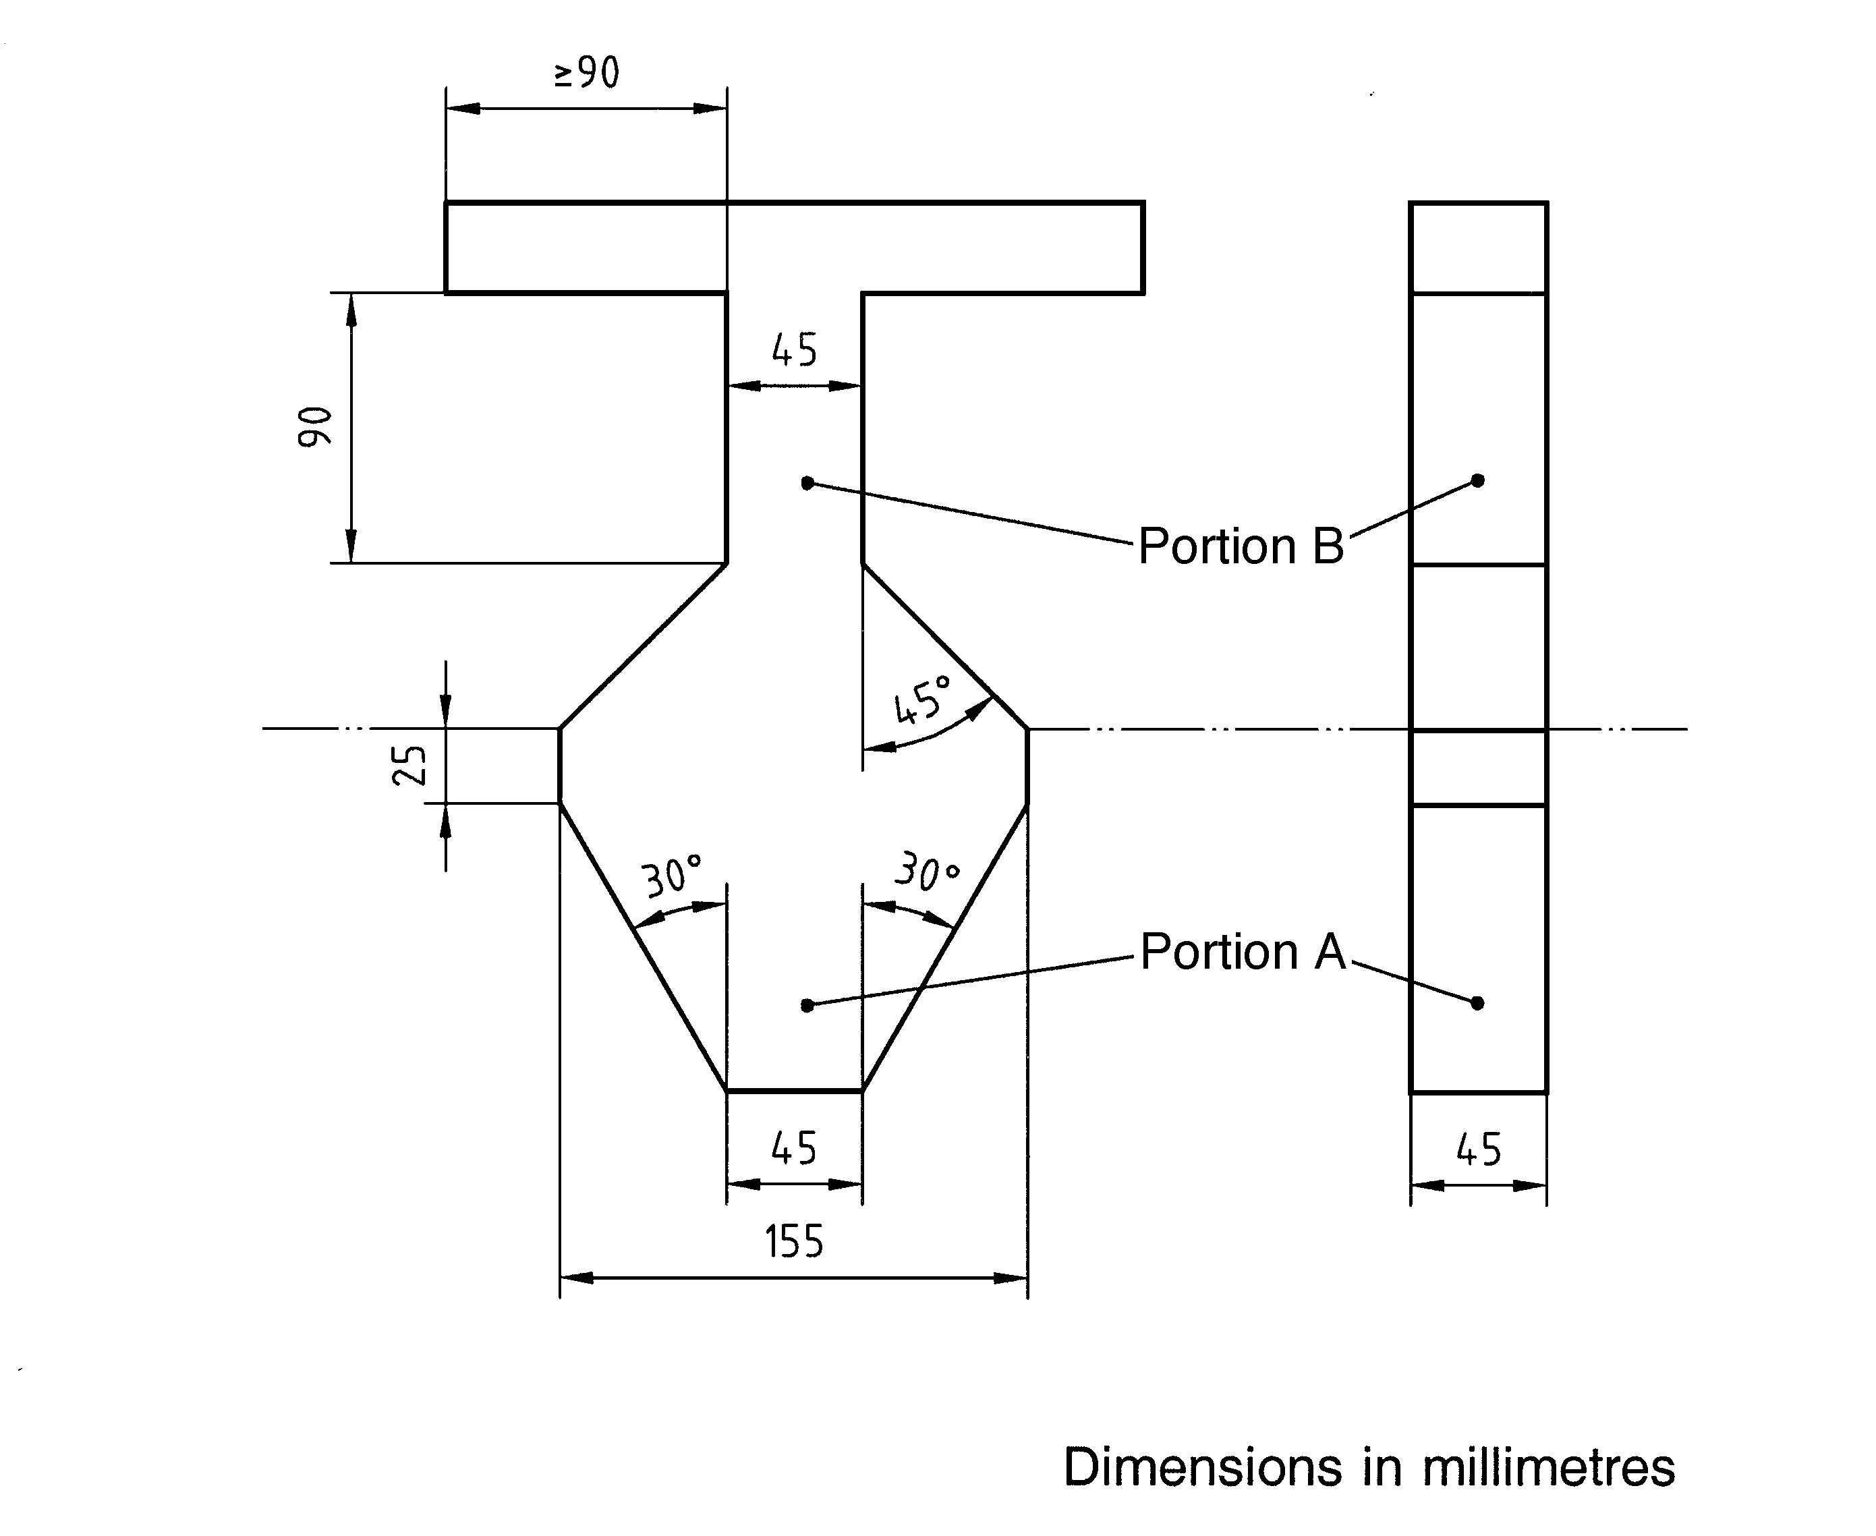
Key
  - Portion B
  - Portion A
Figure C1 – Test template for assessment of head and neck entrapment in partially bound and v-shaped openings

C4.2.2.2 Procedure
Position the ’B’ portion of the test template between and perpendicular to the boundaries of the opening, as shown in figure C2. Record and report whether the template fits within the boundaries of the opening or if it cannot be inserted to its full thickness.

If the test template can be inserted to a depth greater than the thickness of the template (45 mm), apply the ’A’ portion of the test template, so that its centre line is in line with the centre line of the opening. Ensure that the plane of the test template is parallel and applied in line with the opening, as shown in figure C3.

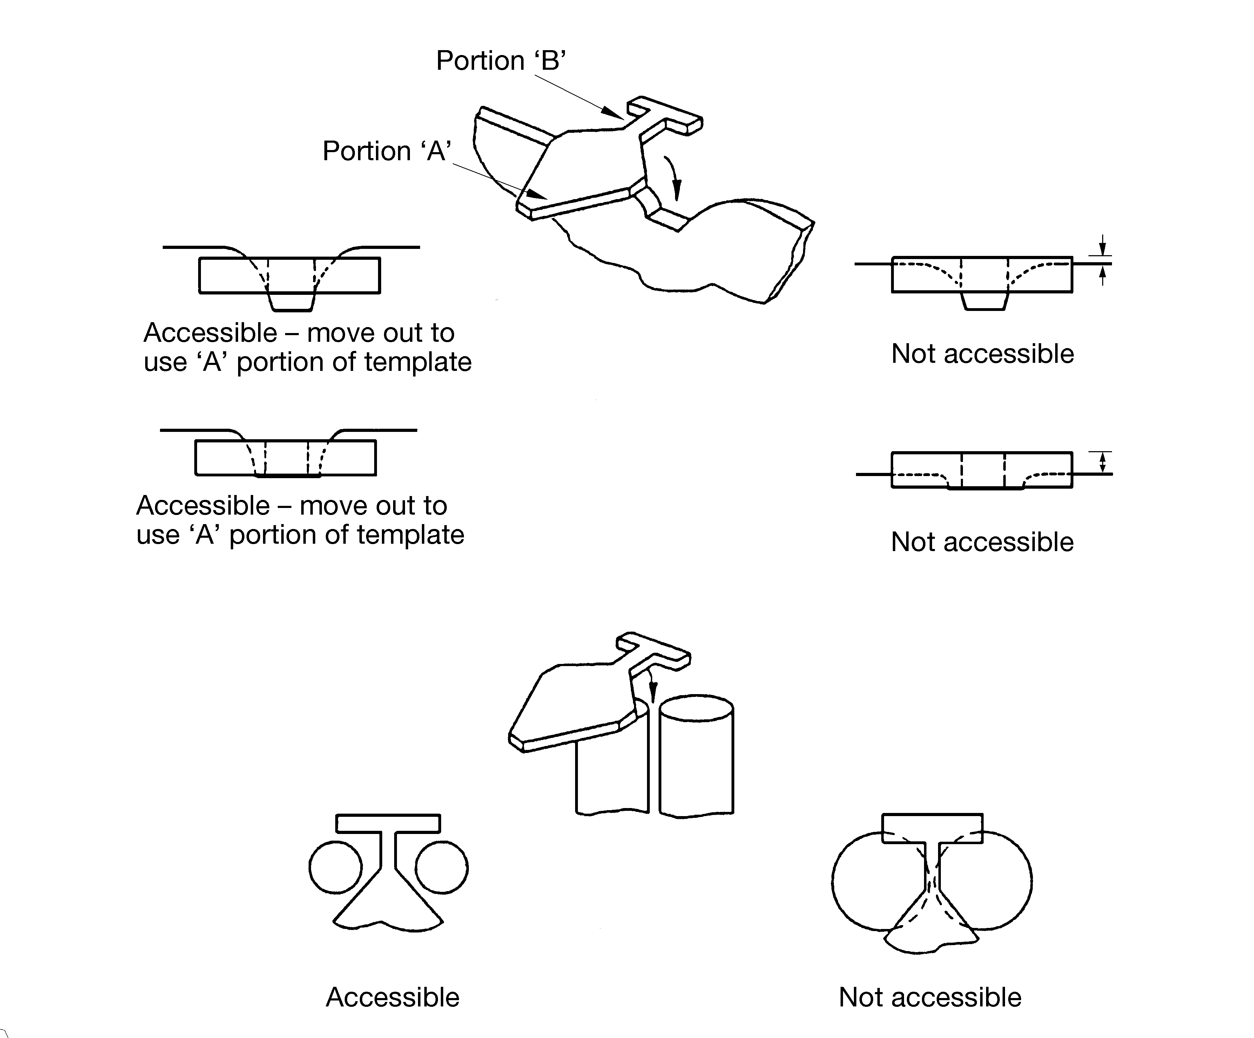

Figure C2 – Method of insertion of the ‘B’ portion of the test template

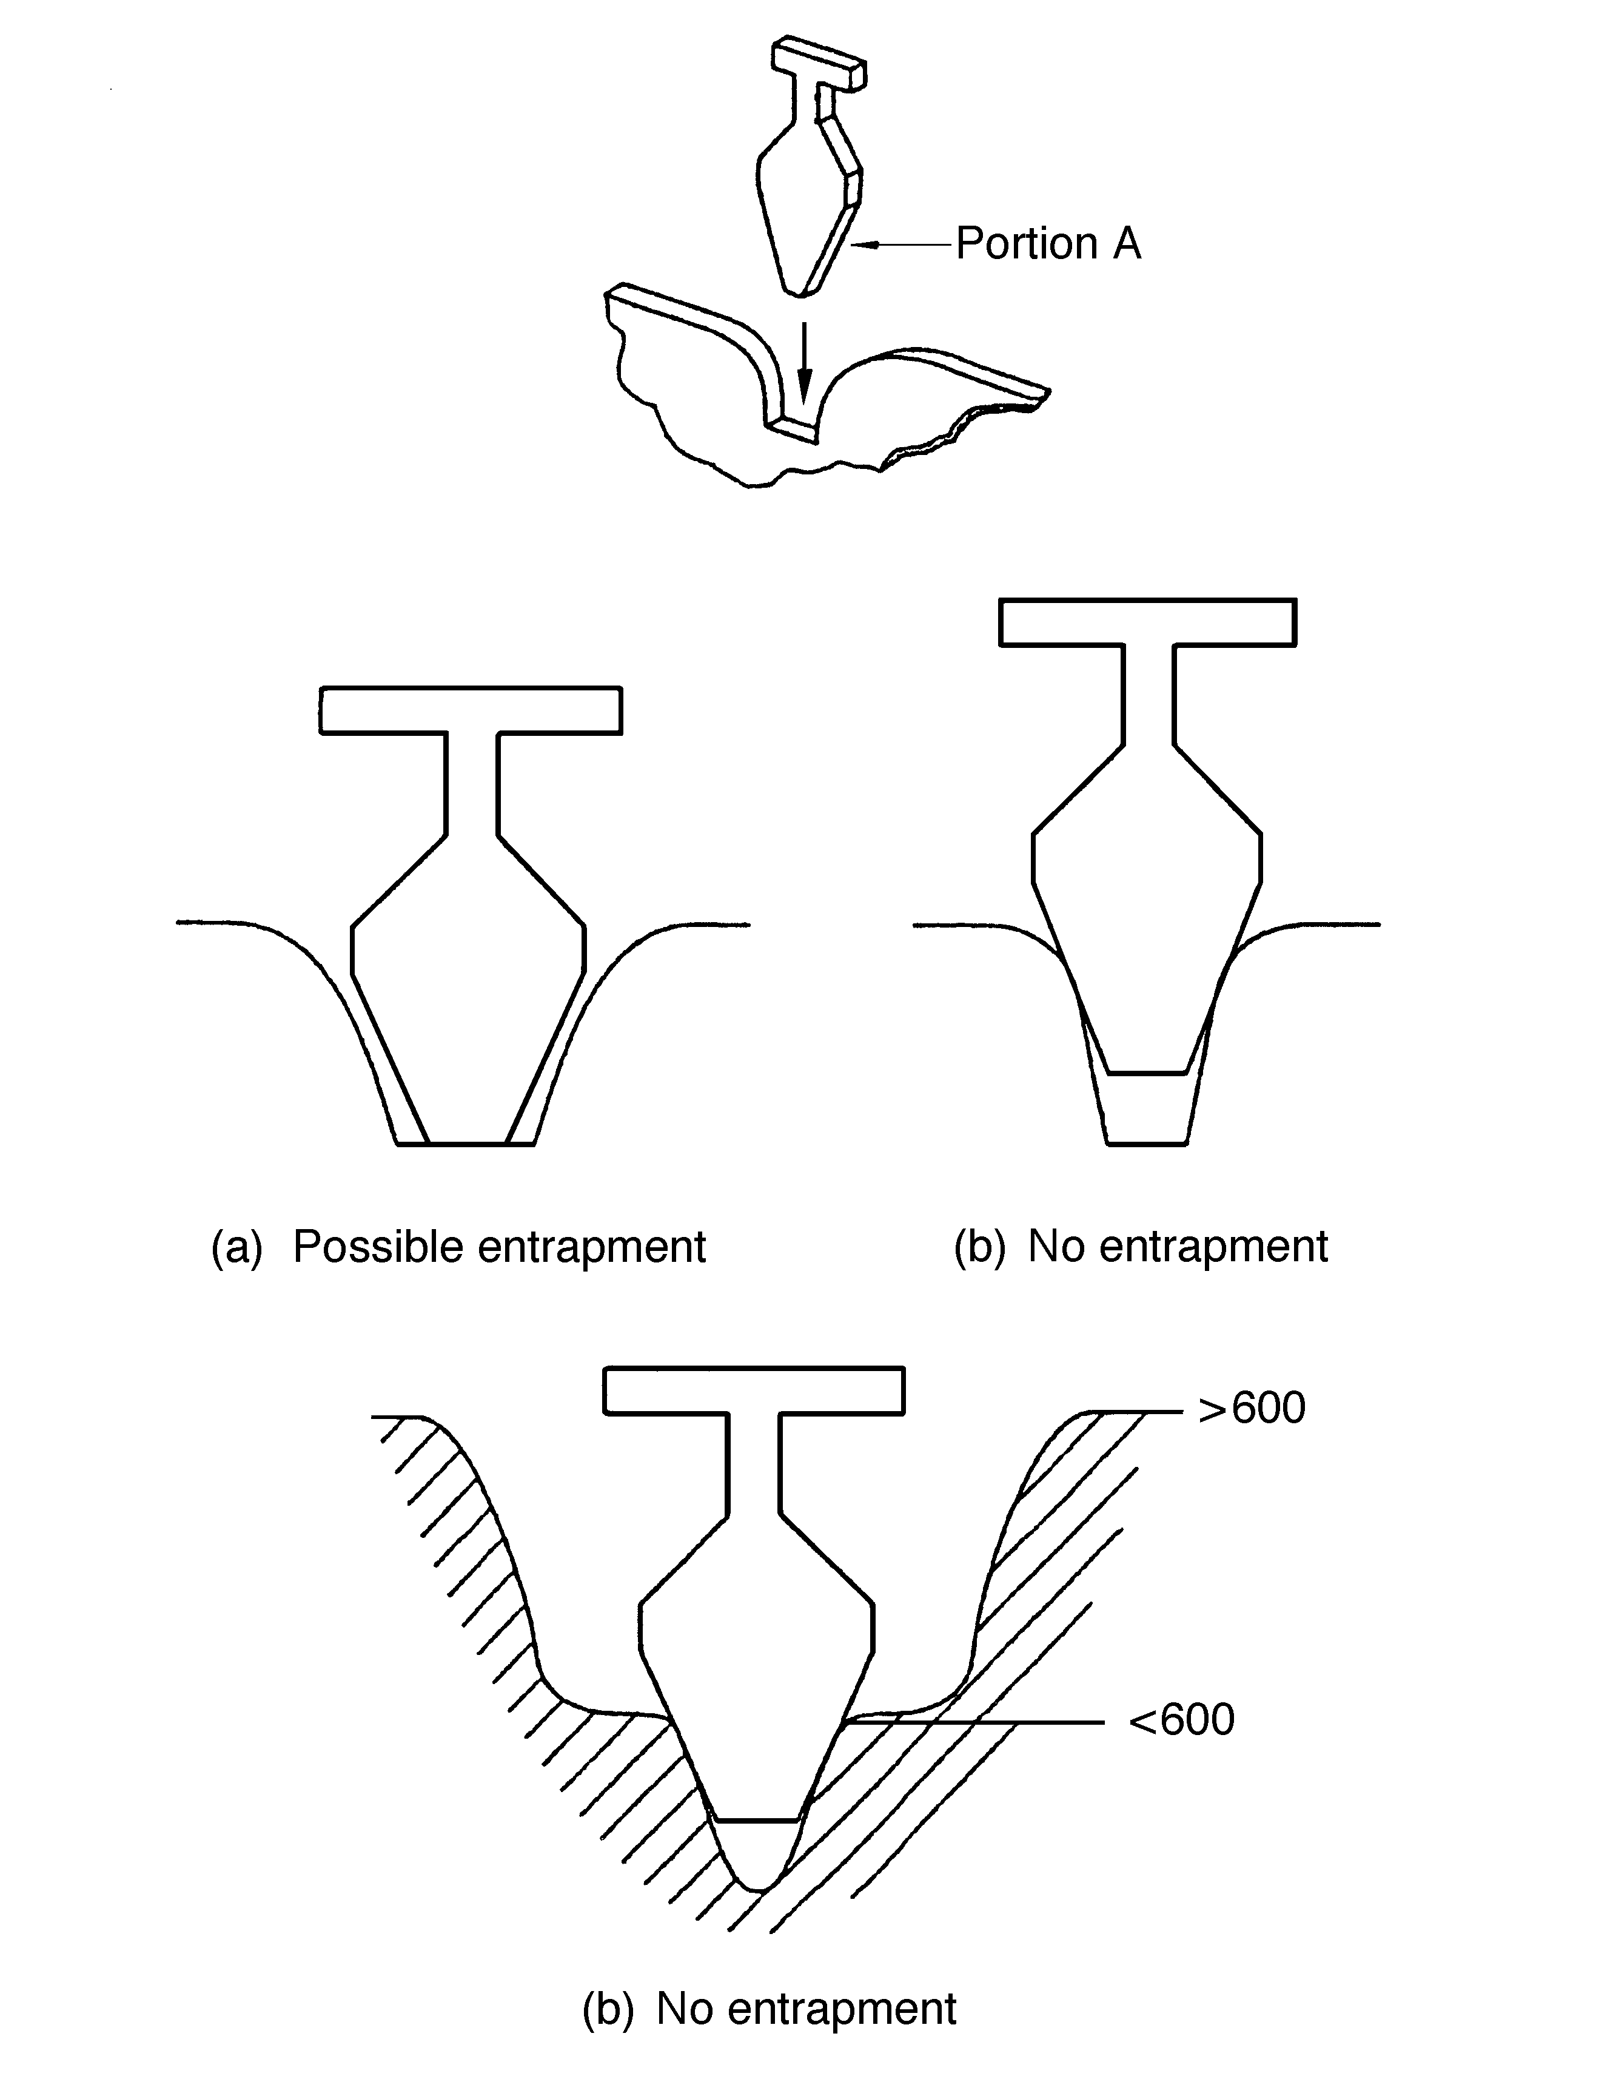
Key
a passes
b fails
Figure C3 – Method of insertion of the ‘A’ portion of the test template

Insert the test template along the centre line of the opening until its motion is arrested by contact with the boundaries of the opening. Record and report the results.

C3.1 Finger entrapment

C3.1.1 Apparatus

Finger rods are illustrated in figure C4.

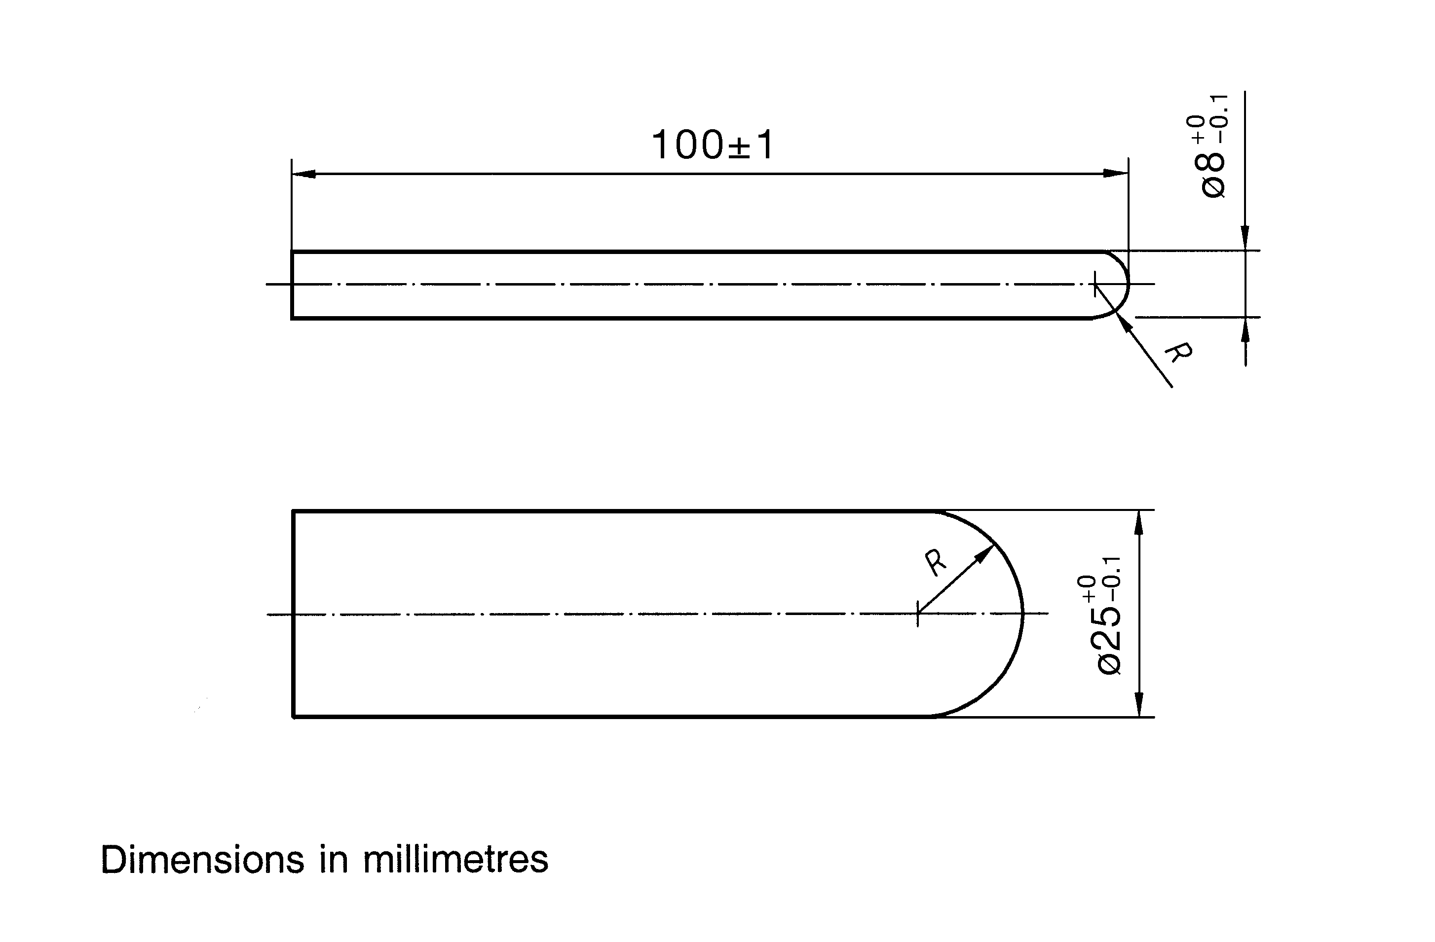
Figure C4 – Finger rods

C3.1.2 Procedure
Apply the 8 mm diameter finger rod to the minimum cross section of the opening and, if the rod does not pass through, rotate it as illustrated in figure C5.

Record and report if the rod passes through the opening and if it locks in any position when rotated.

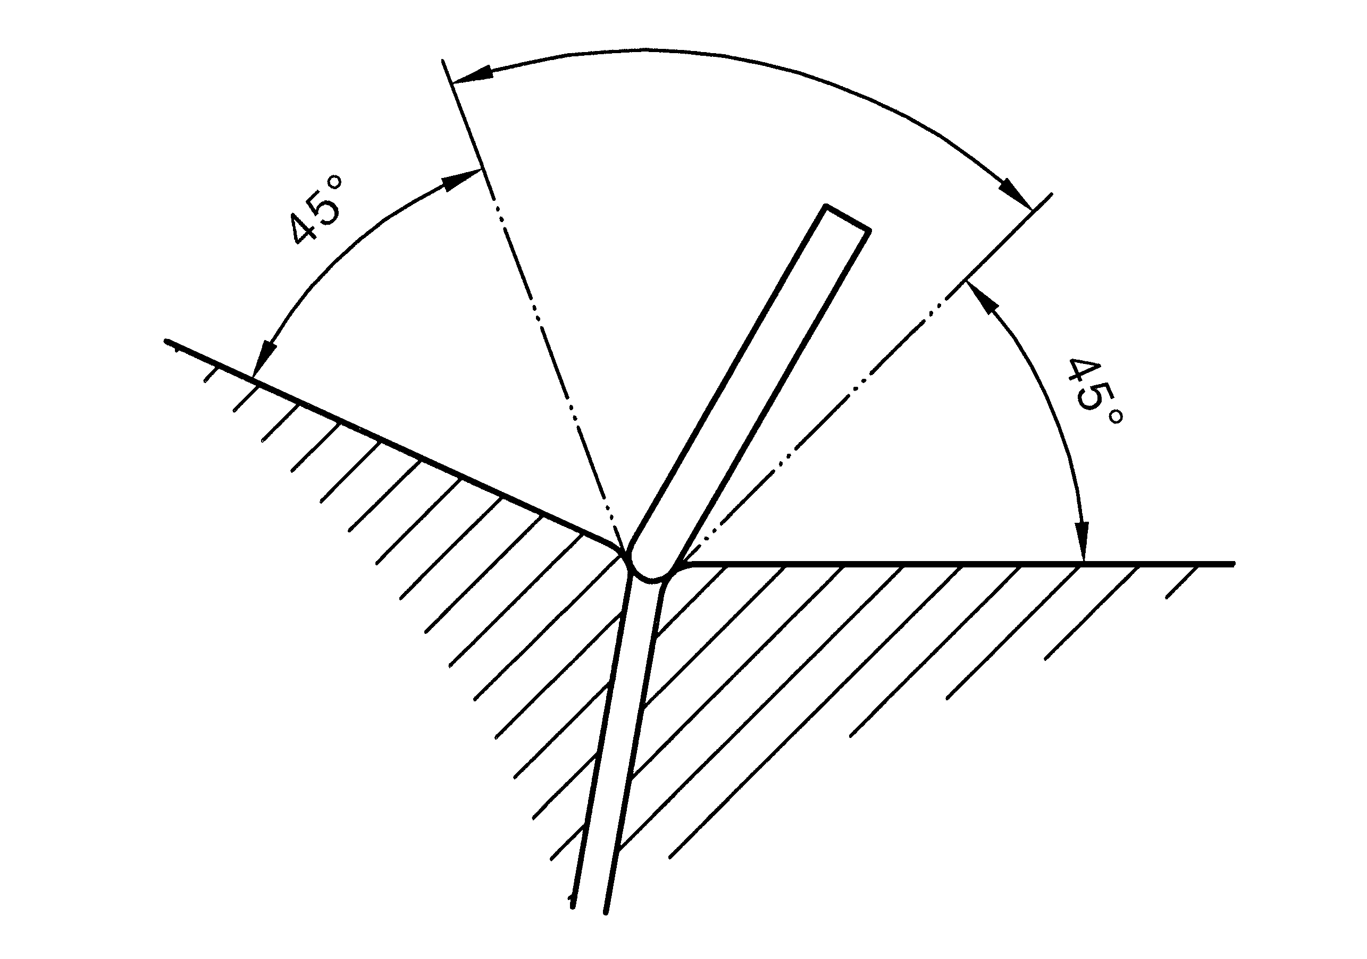
Figure C5 – Rotation of the 8 mm diameter finger rod
If the 8 mm diameter finger rod passes through the opening, apply the 25 mm diameter finger rod. Record and report if the 25 mm diameter finger rod passes through the opening.

APPENDIX D

PRECOAT FILTER MEDIUM SELECTION

(Informative)

D1 The selection of the precoat filter medium is a critical factor that affects the filtration removal efficiency of dirt particles over the relevant particle size ranges. Diatomaceous earth (DE) and cellulose products are available in various grades and within these two generic media groups there are significant variations in the removal performance for products of equal permeability. It is therefore essential that filter suppliers be required to provide reliable test data or case history specific to the selected combination of filter and precoat medium. Ideally, the test data supplied should come from a recognised testing laboratory and demonstrate filter permeability and removal efficiency over a range of challenge particle sizes down to 3 microns.

D2 Precoat media typically fall into one of three generic types (DE, perlite and cellulose) and within each generic type various grades are available. The filtration removal efficiency of dirt particles in the various size ranges can vary widely for each type and grade of medium.

It is desirable that infective cysts of Giardia (size range typically 8 to 12 microns) and Cryptosporidia oocysts (size range typically 4 to 6 microns) are removed by the filters. Limited information suggests that for correctly precoated filters, appropriate grades of DE will generally remove a higher proportion of particles in the 3 to11 micron range than either perlite or cellulose.

It is desirable that filter suppliers be required to provide reliable filter performance test data specific to the selected filter and precoat medium.

D3 Refer to material safety data sheets when selecting the filter medium. Be aware that DE contains a proportion of crystalline silica which in the respirable (airborne) form has been classified by the International Association for Research on Cancer as a Class 1 carcinogen. When inhaled it can cause silicosis and irritate the respiratory system and in high airborne concentrations may irritate eyes. Skin contact or ingestion are not considerd to be hazardous. To provide a perspective it should be noted that Class 1 carcinogens include cement dust, road dust, and calcium silicate wall board dust. Breathing and eye protection in accordance with material safety data sheet recommendations must be worn by operators handling the product. It is recommended that an extract ventilation system with capture hood and arresting air filter be installed local to the point where DE dust may be generated.

D4 Spent DE waste may cause blockage if discharged to site and utility drains. Check the requirements of the local authority. Generally it is preferable that the bulk of the spent DE is removed in a settling vessel, or by a series of screens or filter bags.

APPENDIX E

BALANCE TANK OPERATION

(Informative)

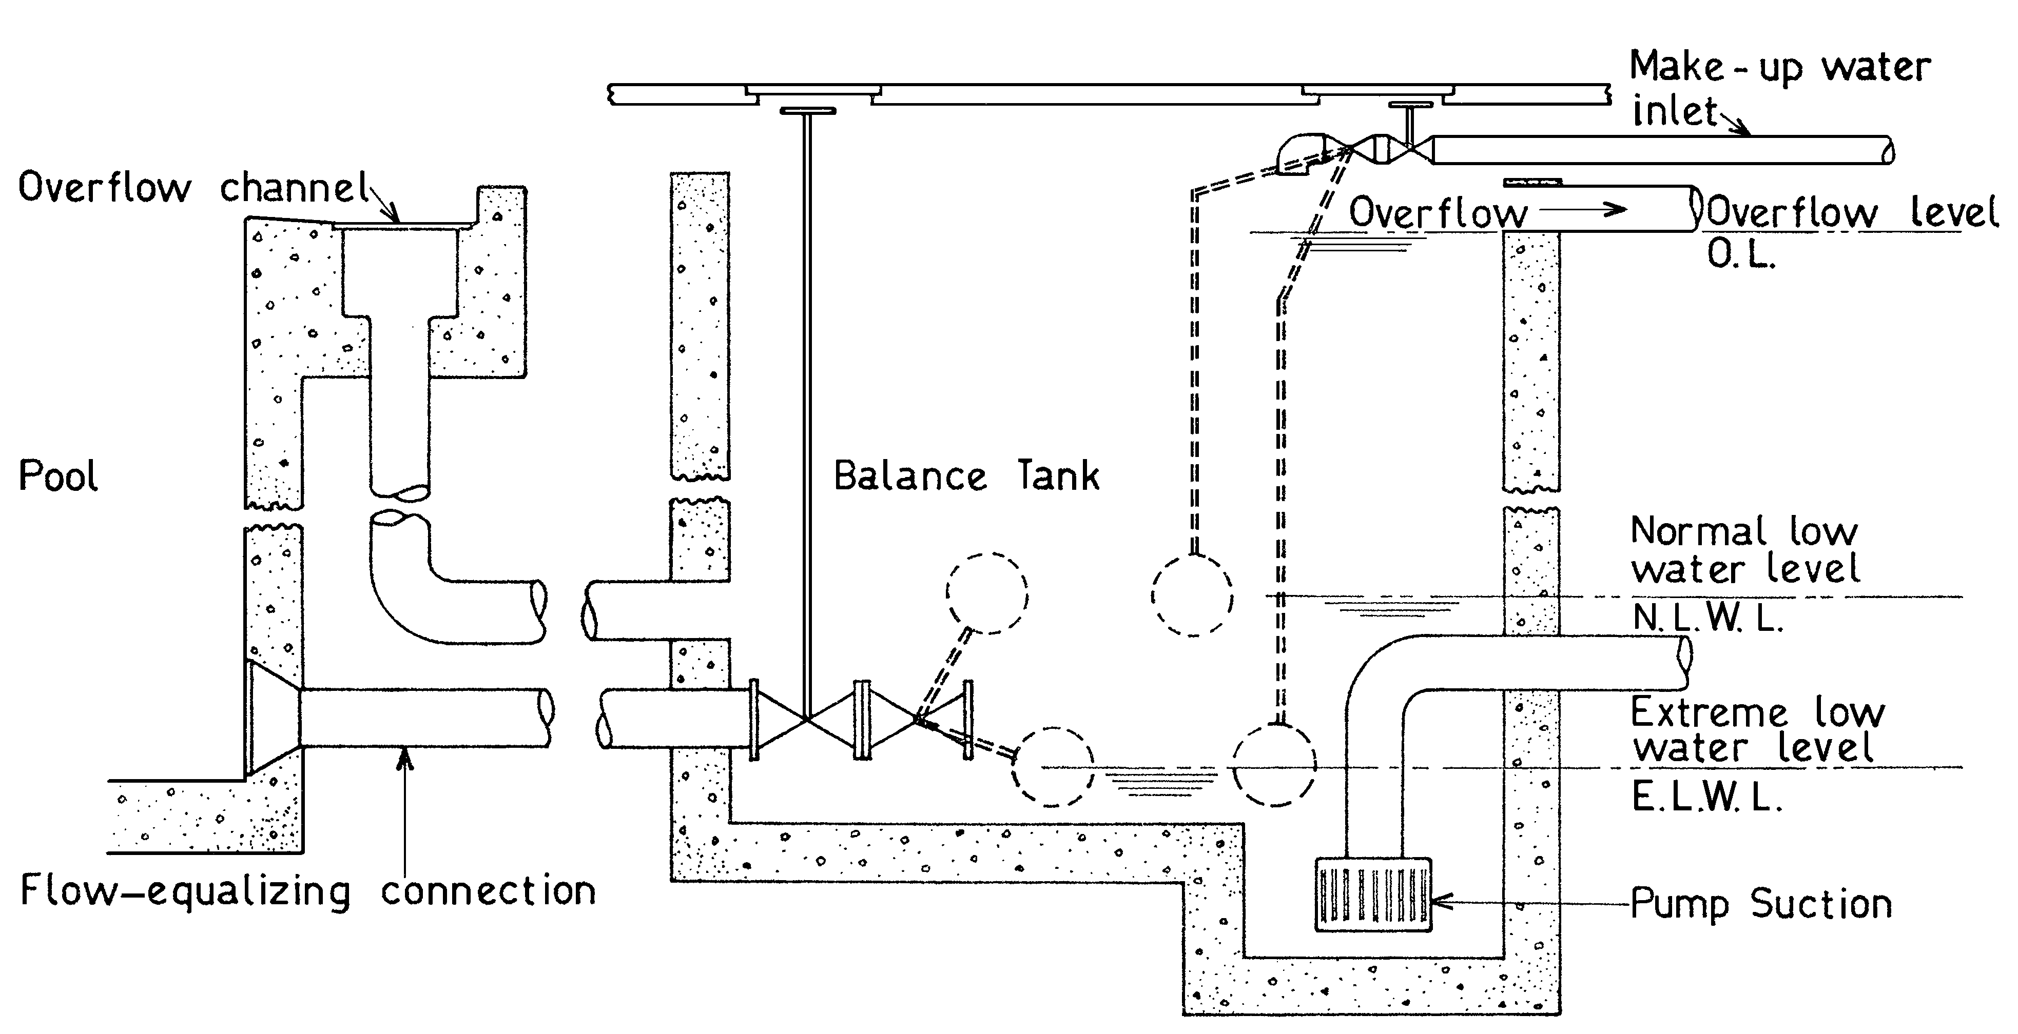

- Diagrammatic representation of balance tank showing inlets, outlets (drain omitted) and water levels. Note that this diagram is not to scale and is simplified by the omission of several features required by this Standard.

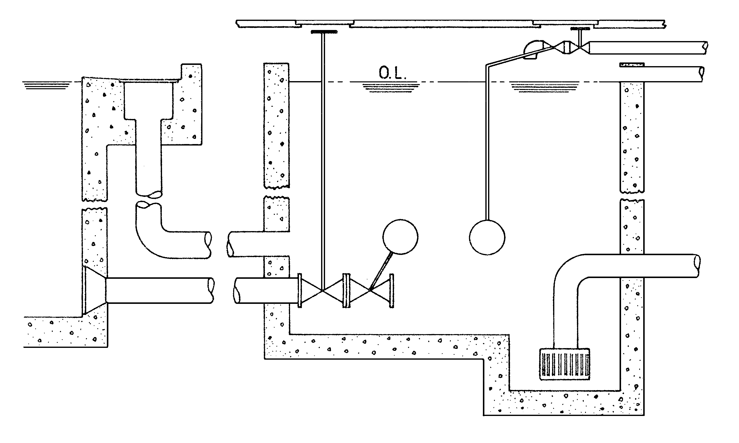
- No-flow condition, as at the start of the season. Slow leakage through the flow-equalising connection has bought both tank and pool water levels to O.L.

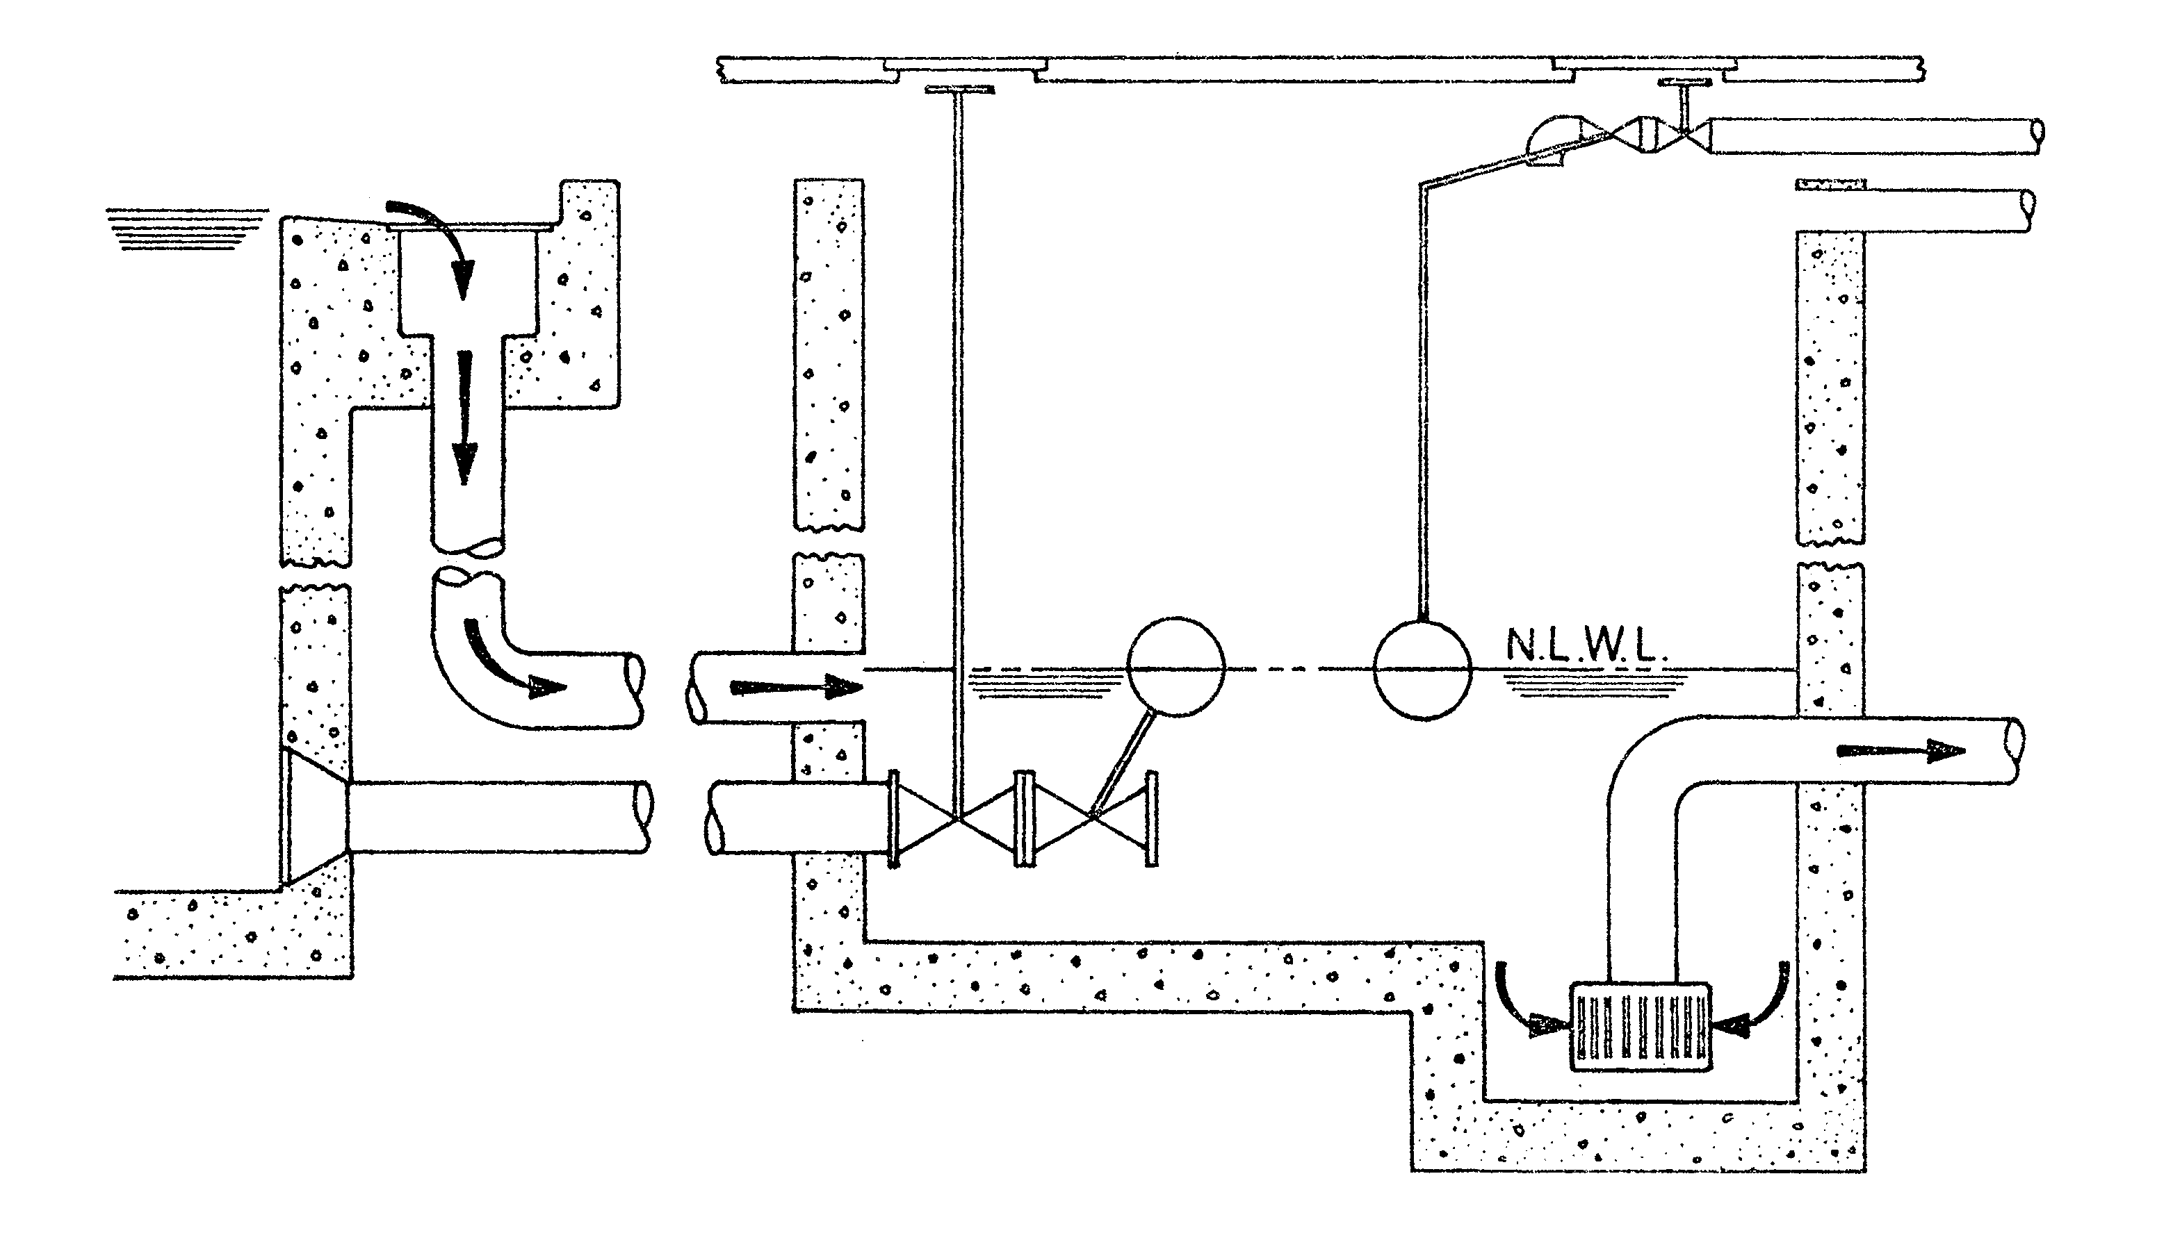
- Pump running; no bather, no wind or wave action. Tank water level: NLWL. Make-up water inlet; Closed. Flow equalising connection: Closed.

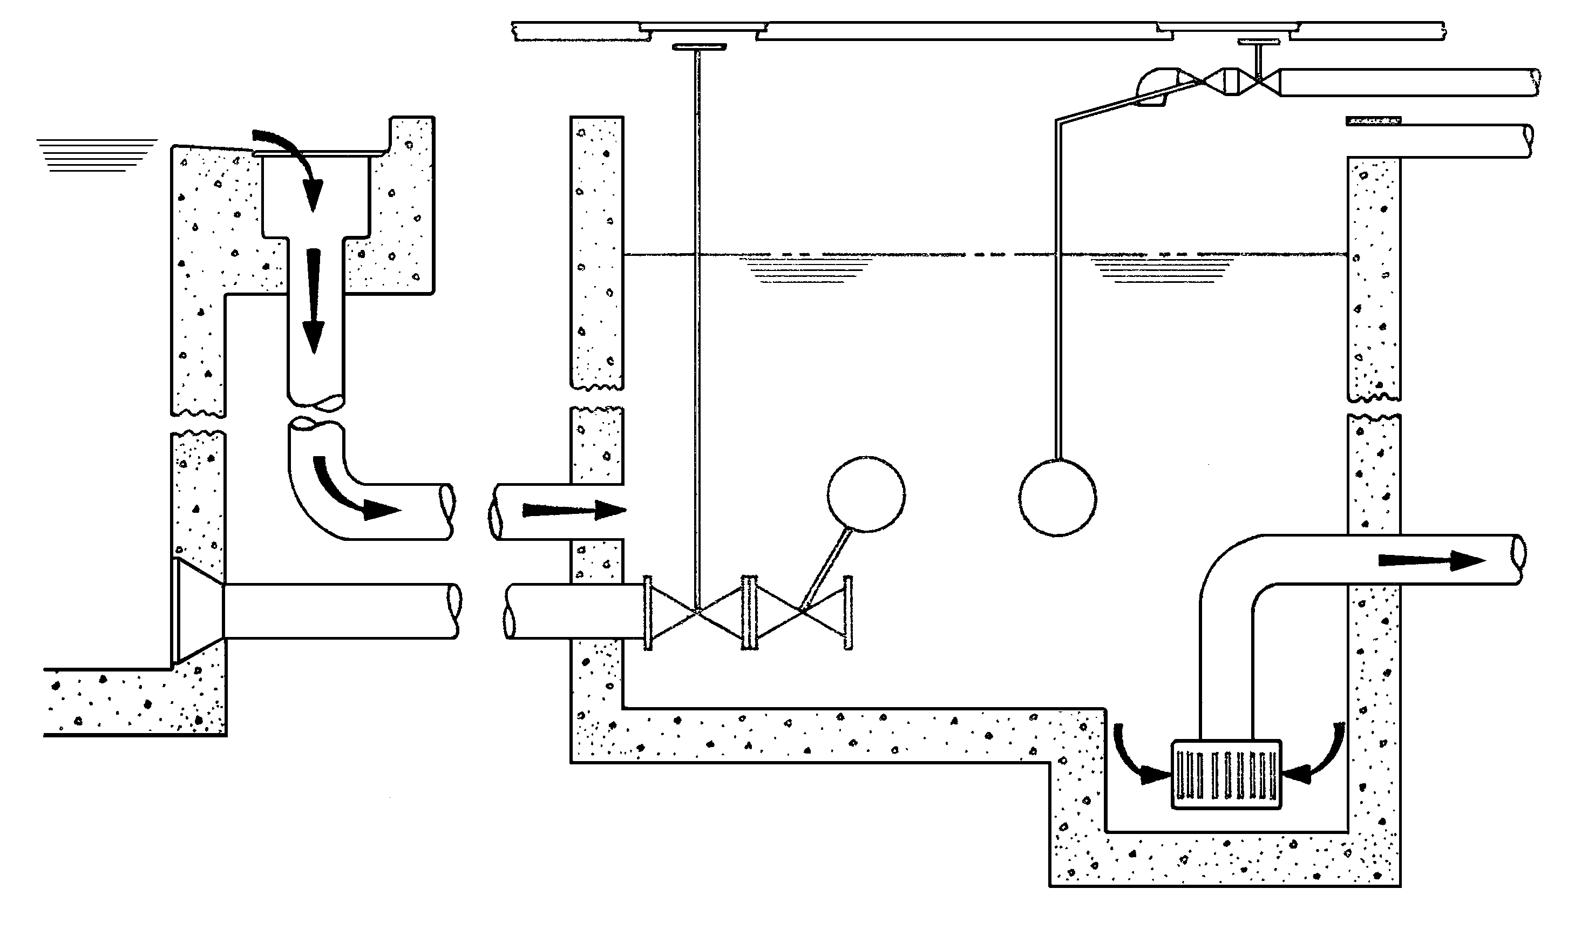
- Pump running; bathers in pool have displaced water and so raised balance tank water level. Tank water level: Between N.L.W.L. and O.L. Make-up water inlet: Closed. Flow equalising connection: Closed.

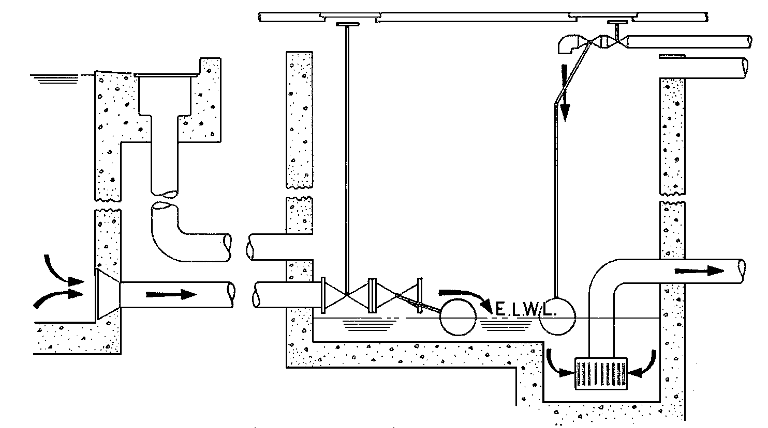

- Pump running; deficiency of water in system (e.g. immediately after back washing). Tank water level: E.L.W.L. Make-up water inlet: Open flow equalising connection: Open equalising connection may close before this stage is reached.

Figure E1 – Operation of a balance tank

